Purpose: |  |  |  |  | To ensure team members participate good safety practices whilst using the Baler Recycling Station
Responsibilities: |  |  |  |  | All Personnel
Personal Protective Equipment
  Safety Glasses |   Gloves |  |   Safety Footwear |  |  |   Ear plugs/Muffs |   Face shields |  |   High Visibility Vest/Clothing | Safety Hat | Safety Harness |   Protective Clothing |   Safety Mask |  | OTHER  Cold and Weather protection as required | NO PPE REQUIRED
Pre Start Checks |  |  |  |  |  |  |  |  |  |  |  |  |  | Potential Hazards
- Dressed appropriately for work with correct PPE  - Check for blockages  - Check that all covers and guards are intact*  - Check that there are no oil leaks on the machine*  - Check that the electrical supply cable is intact and properly protected against impact*  - Closed toed non slip shoes  - Work area clear to operate safely  - Floor clean and free of spillages  - Fit for work  - First aid kit on hand  *If any faults are discovered in the functions listed above, the machine must not be used until it has been repaired by authorised service personnel. |  |  |  |  |  |  |  | 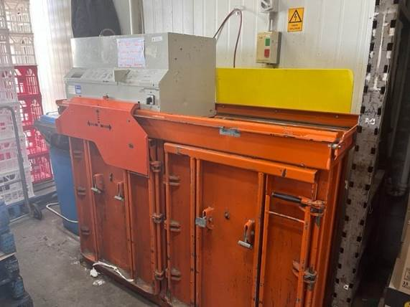 |  |  |  |  |  | - High hydraulic pressure  - Electrical  - Manual handling  - Clearing blockages
Procedure
Steps |  | Instructions
1  Plan the work |  |  |  | - DO NOT operate the machinery without training on the control panel, operations manual and safety features  - Undertake all prestart checks  - Ensure you are wearing any required PPE (closed shoes), roll up sleeves, all loose clothing and tied back loose hair and clothing.  - Check other activity in the vicinity - Only the operator is allowed in the machine working area
2  Conduct the work |  |  |  | - Prepare the machine with baler strapping wire  - Place the waste evenly distributed in the chamber  - Pull the compaction unit over the waste using both hands  - Press the lever for an automatic press cycle  - Pull the strap over the waste and cut  - Place a pallet/trolley and eject the cardboard bale onto the pallet/trolley.  - NEVER leave the recycling station unattended  - Turn off the machine once task is complete
Safety tips |  |  |  | - Never climb on the machine  - Do not work inside the machine  - Use both hands when pushing the press unit over the next chamber  - Do not fill higher than 100 mm from the top of the chamber  - DO NOT overfill the chamber  - Use only the straps recommended by the machine manufacturer  - To clear trapped waste disconnect the machine

Training |  | trainee I acknowledge and understand the SWP and the training I have received.  Trainer: The trainee has been told and shown what a compliant standard looks like when conducting this task safely, the key risks have been emphasised, and the requirements of the process have been clearly communicated.
Trainee Name: |  | Trainee Signature: Payroll Number: Date:
Trainer Name: |  | Trainer Signature: Payroll Number: Date:
Competency | trainee: I have the knowledge and skills to undertake this task confidently and safely.  Trainer: The trainee has demonstrated confidence, understanding and competency in conducting this task safely.
Trainee Name: |  |  | Trainee Signature: | Date:
Competent Person: |  |  | Competent Person Signature: | Date:

