Purpose: |  |  |  |  | To ensure team members participate good safety practices whilst using the Thompson Bandsaw
Responsibilities: |  |  |  |  | Butchery Personnel
Personal Protective Equipment
  Safety Glasses |   Gloves |  |   Safety Footwear |  |  |   Ear plugs/Muffs |   Face shields |  |   High Visibility Vest/Clothing | Safety Hat | Safety Harness |   Protective Clothing |   Safety Mask |  | OTHER  Cold and Weather protection as required | NO PPE REQUIRED
Pre Start Checks |  |  |  |  |  |  |  |  |  |  |  |  |  | Potential Hazards
- Dressed appropriately for work with correct PPE  - Check the electrical parts, emergency stop and stopping time, lighting is good  - Locate and ensure you are familiar with all machine operations and controls  - Ensure the blade is sharp to avoid force and drag  - Check that metal guide on the table is not damaged  - Closed toed nonslip shoes  - Work area clear to operate safely  - Floor clean and free of spillages  - Fit for work  - First aid kit on hand |  |  |  |  |  |  |  | 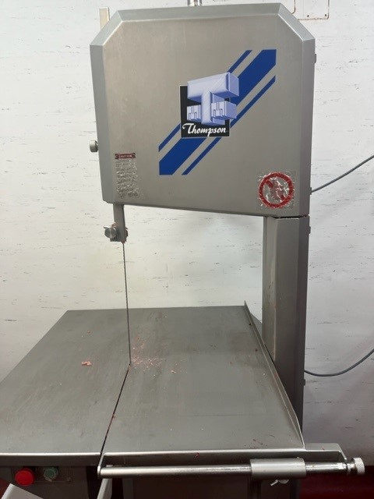 |  |  |  |  |  | - Contact with blade during cutting or removing product  - Manual handling (repetitive movements)
Procedure
Steps |  | Instructions
1  Plan the work |  |  |  | - DO NOT operate the machinery without training  - Undertake all prestart checks  - Ensure you are wearing any required PPE (apron, closed shoes), roll up sleeves, all loose clothing and tie back loose hair and clothing.  - Ensure you have enough space to avoid knocks  - Ensure any electrical leads are in good condition and not in a position to be cut or damaged.  - Ensure you have enough room for the products and trays or containers ready to receive the meat.  - Assess the product. Never attempt to cut small products. The product should be firm and be on the approved list to cut using the Bandsaw.
2  Conduct the work |  |  |  | - Feed the product forward evenly and hold it firmly on the table to ensure effective control during cutting while keeping hands in safe position  - Push the product off the table. Never reach past the blade to retrieve cuts  - Before making adjustments, switch off the saw and bring the machine to a complete standstill  - Stop the machine before attempting to back the work away from the blade  - Stop the work immediately if there is an issue with the blade and report it  - Operate a clean as you go policy to ensure the floor is kept clean  - Turn off the machine once task is complete
3  Cleaning |  |  |  | - Power must be turned off when cleaning  - Separate and wash all parts by hand and dry thoroughly. Protective/cut-resistant gloves must be used whenever handling the blades.  - Leave the machine in a safe, clean and tidy state.
3  Safety Tips |  |  |  | - The bandsaw should be sited where the operator can have plenty of space  - Keep fingers clear of the moving attachments at all times. Failure to do so may result in personal injury.  - NEVER reach past the blade to retrieve cuts or get another person to pull off product  - Certain high risk operations should not be carried out with an open bladed bandsaw: these include:  - The cutting of fresh meat that necessitates approach of the fingers to the blade less than 50mm  - Trimming of butt ends of lamb carcases (that is, trimming off the thick fatty ends).  - Preparation of fresh pork chops from loin of pork.  - Cutting cooked chickens in half by hand feeding.  - NEVER cut legs and shoulders on a bandsaw from fresh killed carcasses  - NEVER use any accessories or parts from other manufacturers  - ALWAYS REMOVE ties, rings, watches, bracelets, or other jewellery before operating.

Training |  | trainee I acknowledge and understand the SWP and the training I have received.  Trainer: The trainee has been told and shown what a compliant standard looks like when conducting this task safely, the key risks have been emphasised, and the requirements of the process have been clearly communicated.
Trainee Name: |  | Trainee Signature: Payroll Number: Date:
Trainer Name: |  | Trainer Signature: Payroll Number: Date:
Competency | trainee: I have the knowledge and skills to undertake this task confidently and safely.  Trainer: The trainee has demonstrated confidence, understanding and competency in conducting this task safely.
Trainee Name: |  |  | Trainee Signature: | Date:
Competent Person: |  |  | Competent Person Signature: | Date:

