Purpose: |  |  |  |  | To ensure team members participate good safety practices whilst using the Thompson Meat Mincer
Responsibilities: |  |  |  |  | Butchery Personnel
Personal Protective Equipment
  Safety Glasses |   Gloves |  |   Safety Footwear |  |  |   Ear plugs/Muffs |   Face shields |  |   High Visibility Vest/Clothing | Safety Hat | Safety Harness |   Protective Clothing |   Safety Mask |  | OTHER  Cold and Weather protection as required | NO PPE REQUIRED
Pre Start Checks |  |  |  |  |  |  |  |  |  |  |  |  |  | Potential Hazards
- Dressed appropriately for work with correct PPE  - Closed toed non slip shoes  - Work area clear to operate safely  - Ensure guards are fitted, secure and functional  - Floor clean and free of spillages  - Fit for work  - First aid kit on hand |  |  |  |  |  |  |  | 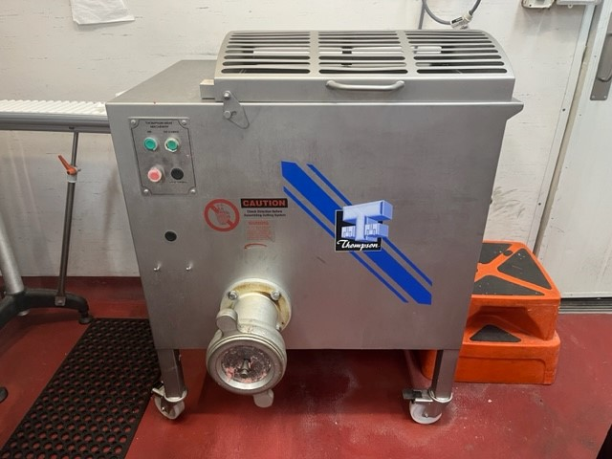 |  |  |  |  |  | - Shear traps on the worm from the in-feed side.  - Access to the blades or knives, through discharge openings.  - Handling blades and plates etc particularly when freeing jams and stripping the machine down for cleaning.  - Sudden jerking movements from the push stick, during feeding.  - Dangers arise when the operators might be tempted to move the parts under power both when the machines are being fed and emptied and also during cleaning.
Procedure
Steps |  | Instructions
1  Plan the work |  |  |  | - DO NOT operate the machinery without training  - Ensure you are wearing any required PPE (apron, closed shoes), roll up sleeves, all loose clothing and tie back loose hair and clothing.  - Check the mincer, ensure it is clean, the blades have been correctly installed and operational with no blockages.  - Ensure any electrical leads are in good condition and not in a position to be cut or damaged.  - Ensure you have enough room for the products and trays or containers ready to receive the meat.
2  Conduct the work |  |  |  | - Empty meat into the feed opening. Always keep your hands out of the opening and behind the guards. NEVER REACH INTO the grinder or force the meat into the Blades.  - Interlock the guard  - Once work is complete switch turn off Meat Mincer.
3  Cleaning |  |  |  | - Power must be turned off before cleaning starts  - Separate and wash all parts by hand and dry thoroughly.  - Protective/cut-resistant gloves must be used whenever handling the blades.
3  Safety Tips |  |  |  | - Keep fingers clear of the moving attachments at all times. Failure to do so may result in personal injury.  - DO Not operate machine when empty  - DO NOT press or push meat into the worm with your fingers or any other object. Doing so may cause personal injury and/or damage to the unit.  - NEVER use fingers to scrape food away from the feeder hole while in operation. SEVERE INJURY MAY RESULT.  - DO NOT dislocate the safety guards during the meat mincing process  - DO NOT push the Tongs or other utensils into the Blades.  - NEVER LEAVE THE Meat Mincer UNATTENDED.  - NEVER use any accessories or parts from other manufacturers.  - DO NOT attempt to tenderize or slice meat with bones or other hard items. Damage to the machine will occur.  - REMOVE ties, rings, watches, bracelets, or other jewellery before operating.

Training |  | trainee I acknowledge and understand the SWP and the training I have received.  Trainer: The trainee has been told and shown what a compliant standard looks like when conducting this task safely, the key risks have been emphasised, and the requirements of the process have been clearly communicated.
Trainee Name: |  | Trainee Signature: Payroll Number: Date:
Trainer Name: |  | Trainer Signature: Payroll Number: Date:
Competency | trainee: I have the knowledge and skills to undertake this task confidently and safely.  Trainer: The trainee has demonstrated confidence, understanding and competency in conducting this task safely.
Trainee Name: |  |  | Trainee Signature: | Date:
Competent Person: |  |  | Competent Person Signature: | Date:

