Purpose: |  |  |  |  | To ensure team members participate good safety practices whilst using the KP Tenderiser .
Responsibilities: |  |  |  |  | Butchery Personnel
Personal Protective Equipment
  Safety Glasses |   Gloves |  |   ☑  Safety Footwear |  |  |   Ear plugs/Muffs |   Face shields |  |   High Visibility Vest/Clothing |   Safety Hat | 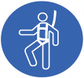  Safety Harness |   Protective Clothing |   Safety Mask |  | OTHER  Cold and Weather protection as required | NO PPE REQUIRED
Pre Start Checks |  |  |  |  |  |  |  |  |  |  |  |  |  | Potential Hazards
- Dressed appropriately for work with correct PPE  - Closed toed non slip shoes  - Work area clear to operate safely  - Floor clean and free of spillages  - Fit for work  - First aid kit on hand |  |  |  |  |  |  |  | 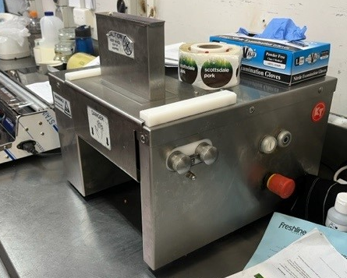 |  |  |  |  |  | - Contact with serrated tenderising blades  - Infeed and outfeed conveyors  - Electrical hazards  - Manual handing (repetitive tasks)
Procedure
Steps |  | Instructions
1  Plan the work |  |  |  | - DO NOT operate the machinery without training  - Ensure you are wearing any required PPE (apron, closed shoes), roll up sleeves, all loose clothing and tie back loose hair and clothing.  - Check the tenderiser, ensure it is clean, the blades have been correctly installed and operational with no blockages.  - Ensure any electrical leads are in good condition and not in a position to be cut or damaged.  - Ensure you have enough room for the products and trays or containers ready to receive the meat.  - Ensure easy access to stop button
2  Conduct the work |  |  |  | - Feed meat into chute using tongs. Always keep your hands out of the opening and behind the guards. NEVER REACH INTO the Tenderiser or force the meat into the Blades.  - Once work is complete turn off Tenderiser  - Wash all parts by hand and dry thoroughly.  - Protective/cut-resistant gloves must be used whenever handling the Tenderiser Blades.
3  Cleaning |  |  |  | - Power is turned off  - Remove blades  - Wipe down machine
4  Safety Tips |  |  |  | - KEEP FINGERS CLEAR OF THE BLADES AT ALL TIMES. Failure to do so may result in personal injury.  - DO NOT press or push meat into the Chute with your fingers or any other object. Doing so may cause personal injury and/or damage to the unit.  - DO NOT immerse the Blades in sudsy water where they cannot be seen  - NEVER use fingers to scrape food away from the Tenderizer while in operation. SEVERE INJURY MAY RESULT.  - DO NOT push the Tongs or other utensils into the Blades.  - NEVER LEAVE THE Tenderizer UNATTENDED.  - NEVER use any accessories or parts from other manufacturers.  - DO NOT attempt to tenderize or slice meat with bones or other hard items. Damage to the machine will occur.  - REMOVE ties, rings, watches, bracelets, or other jewellery before operating.

Training |  | trainee I acknowledge and understand the SWP and the training I have received.  Trainer: The trainee has been told and shown what a compliant standard looks like when conducting this task safely, the key risks have been emphasised, and the requirements of the process have been clearly communicated.
Trainee Name: |  | Trainee Signature: Payroll Number: Date:
Trainer Name: |  | Trainer Signature: Payroll Number: Date:
Competency | trainee: I have the knowledge and skills to undertake this task confidently and safely.  Trainer: The trainee has demonstrated confidence, understanding and competency in conducting this task safely.
Trainee Name: |  |  | Trainee Signature: | Date:
Competent Person: |  |  | Competent Person Signature: | Date:

