Purpose: |  |  |  |  | To ensure the safe use of open fryer
Responsibilities: |  |  |  |  | All personnel
Personal Protective Equipment
  ☑  Safety Glasses |   ☑  Gloves |  | 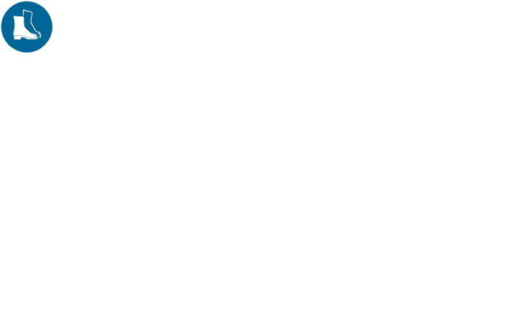  ☑  Safety Footwear |  |  |   Ear plugs/Muffs |   Face shields |  | 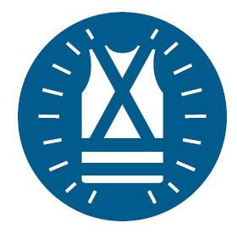  High Visibility Vest/Clothing |   Safety Hat | 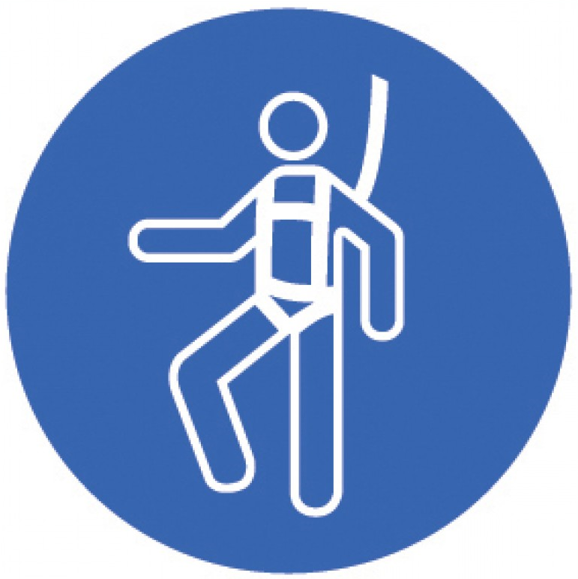  Safety Harness | 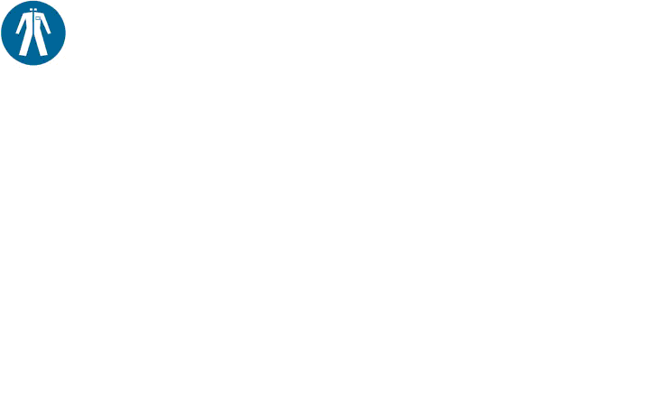  Protective Clothing | 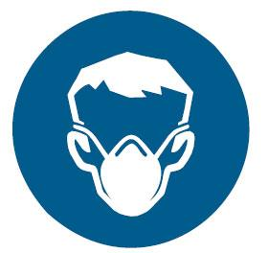  Safety Mask |  | ☑  OTHER  Cold and Weather protection as required | NO PPE REQUIRED
Pre Start Checks |  |  |  |  |  |  |  |  |  |  |  |  |  | Potential Hazards
- Dressed appropriately for work with correct PPE  - Non slip closed shoes, no loose clothing  - Tie hair back and wear a hat  - Heat proof gloves  - Safety glasses *  - Fit for work  - First aid kit on hand  *For use, dispensing and emptying |  |  |  |  |  |  |  | 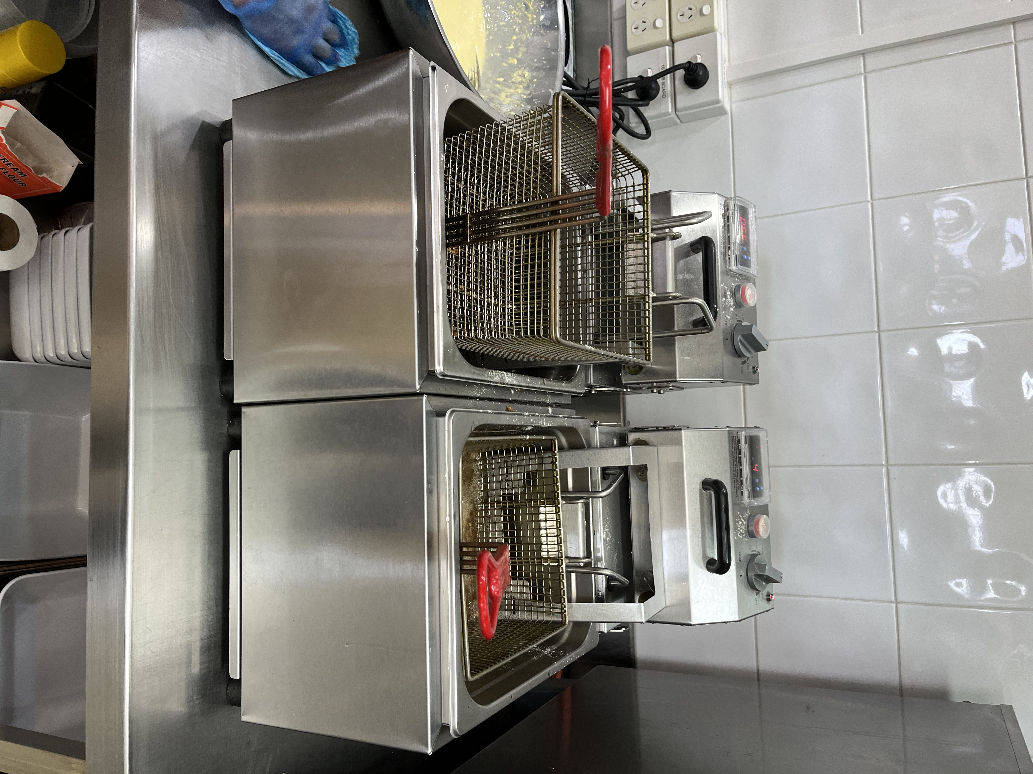 |  |  |  |  |  | - Fire  - burns from hot oil  - contact with hot surfaces  - Fumes from boiling cleaning chemicals  - Boiling chemicals overflowing  - Eye injuries from splashes  - Slips from oil spillage  - Strains and sprains from lifting and moving Containers of oil.
Procedure
Steps |  | Instructions
1  Plan the work |  |  |  | - Ensure the area you will work in is clear of hazards.  - Ensure you have the PPE (gloves, apron, closed shoes) required for the job and you know how to wear it properly.  - If a shared pair of oven gloves is used. Team members should always wear clean, dry inner gloves when using.  - Check all adjustments and settings before commencing any cooking operations  - Ensure the stock you will handle is prepared for cooking and easy to move (on trays etc).  - Always keep your equipment as clean as possible. Cleaning grease off the deep fryer will not only help prevent fires, it is a tick in the hygiene box too.  - Always have a wet chemical or fire blanket in close proximity to your commercial deep fryer in case of emergencies.  - Always place the fryer on a stable and heat resistant surface.
2  Conduct the work |  |  |  | - Wear your PPE when working with hot substances  - Always use a thermometer to check the temperature of the oil and never check the heat using your hand.  - Set the thermostat for most foods between 170-180 degrees Celsius. Melt oil slowly at a low temperature  - Use a frying basket or tongs to lower and remove food from the oil. Always lower food into the fryer and never throw it in, as splashing oil that touches skin is dangerous and painful. When removing a basket from the fryer always use protective gloves. Never use copper or brass utensils  - Always shake water and ice from food before frying and make sure condensation does not drop into oil pot  - NEVER leave the food when it is frying  - Keep your workplace clean and grease-free will prevent slipping and unnecessary accidents.  - Turn off fryer when not in use.  - BEWARE of latent heat. The fryer will hold heat for quite some time.
3  Manual oil filtering |  |  |  | - Turn off the appliance and the power supply at the wall socket for electric appliances, and the on/off control for gas appliances.  - Allow the oil to cool, ideally for at least six hours, and check the temperature using a suitable probe thermometer before draining. Do not drain if the temperature is above 40 °C.  - Follow the manufacturer’s instructions and use the correct equipment (eg a detachable spout for the type of fryer you are emptying), making sure to bring any equipment you need to the fryer before you start.  - Depending on the type of fryer, drain the oil by drain valve, removable spout, lifting container or by tilting.  - If the oil is too cold to drain easily, reheat it briefly and agitate with the fryer basket for no more than one minute. Switch the appliance off and check the temperature again before emptying.  - Using a filter, run the oil into a suitable metal-holding or heat-resistant hard, plastic container. These containers should have carrying handles and a cover or lid. Before moving, make sure that the lid or cover is secure.  - Make sure the container is empty and big enough to take the volume of oil being drained at any time.  - When you are draining large volumes of oil it is safer to drain off in smaller amounts. This avoids overfilling the container and will reduce the chance of spillages when you move it. Smaller amounts will also be easier to carry.  - Place the container in a safe place where it cannot be contaminated with chemicals, water or foreign bodies  - Place the container on top of a drip tray to avoid any floor contamination.  - Do not dispose of waste oil down the drain – disposal must comply with environmental legislation.  - Clean up any spillages immediately.  - Make sure floor areas around equipment are completely clean and dry to avoid slip risks (see also Preventing slips and trips in kitchens and food service).
4  Cleaning procedure |  |  |  | - Turn off the appliance, and the power supply at the wall socket for electric appliances and the on/ off control for gas appliances.  - Wear suitable protective equipment, including eye protection (if appropriate).  - Check that other activities will not be put at risk by the cleaning activity.  - Check that the oil has been thoroughly drained and that there are no spillages that may cause slipping.  - Remove loose debris from the internal surfaces.  - Thoroughly wash all internal and external surfaces with suitable cleaning chemicals and check for any leaks.  - For stubborn residues, fill the fryer with your recommended cleaning agents and leave or simmer according to instructions.  - Do not leave the fryer unattended or allow it to boil as this may cause it to cascade liquid onto the floor, causing additional scalding and slipping hazards.  - Drain the appliance and rinse thoroughly with plenty of water.  - Dry all internal surfaces and make sure there is no water left in the fryer.  - Check the drain valve is closed and working properly, then refill and switch on as required.  - When refilling the fryer with oil, the oil container must be lifted with 2 people and where possible, use smaller containers.  - Do not overfill the fryer. Follow the manufacturer’s guidelines.  - Clean up any spillages immediately.  - Make sure floor areas around the equipment are completely clean and dry to avoid slip risks.

Training | trainee I acknowledge and understand the SWP and the training I have received.  Trainer: The trainee has been told and shown what a compliant standard looks like when conducting this task safely, the key risks have been emphasised, and the requirements of the process have been clearly communicated.
Trainee Name: | Trainee Signature: Payroll Number: Date:
Trainer Name: | Trainer Signature: Payroll Number: Date:
Trainer Name: | Trainer Signature: Payroll Number: Date:
Trainer Name: | Trainer Signature: Payroll Number: Date:
Trainer Name: | Trainer Signature: Payroll Number: Date:
Trainer Name: | Trainer Signature: Payroll Number: Date:

