Purpose: |  |  |  |  | Provide guidance on the safe use of steps and ladders across the Store
Responsibilities: |  |  |  |  | All personnel
Personal Protective Equipment
  Safety Glasses |   ☑  Gloves |  |   ☑  Safety Footwear |  |  |   Ear plugs/Muffs |   Face shields |  |   High Visibility Vest/Clothing |   Safety Hat | 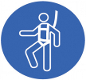  Safety Harness |   Protective Clothing |   Safety Mask |  | OTHER  Cold and Weather protection as required | NO PPE REQUIRED
Pre Start Checks |  |  |  |  |  |  |  |  |  |  |  |  |  | Potential Hazards
- Dressed appropriately for work with correct PPE  - Closed nonslip shoes  - Fit for work  - Work area clear  - First aid kit on hand |  |  |  |  |  |  |  | 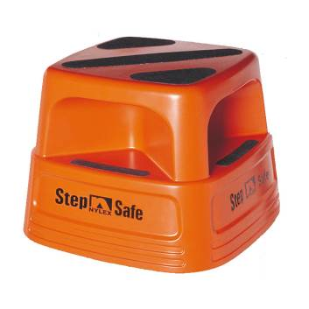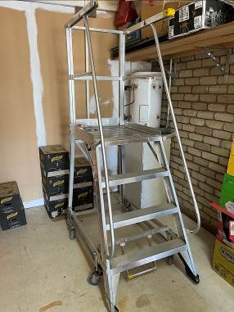  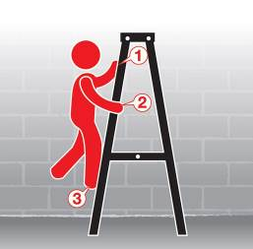 |  |  |  |  |  | - Falls from heights  - Ladders and Steps  - Slips, Trips  - Manual Handling
Procedure
Steps |  | Instructions
1  Plan the work |  |  |  | - Ensure your ladders and steps are in good condition, free from broken parts and ready for the job.  - Ensue your ladders and steps are Australian Standard.  - Choose the right ladder or step for the task.  - Check condition of floor before starting to ensure ladder or step is set up on stable ground  - If the ladder or step you chose will not allow you to easily reach the task, stop and speak to your manager.  - (if deemed necessary) Cordon off the area where you will use the ladder to avoid other bumping you or being struck by dropped objects.
2  Conduct the work |  |  |  | - Once your area of work is clear and ladder or step is set up correctly conduct the task.  - Do not over-reach from the ladder or step, move it if you have to.  - Always move up and down the ladder with three points of contact during the duration of the job.
3  Clean up |  |  |  | - Once the work is complete, put away the ladder or step.  - Report any issues with the ladder or step immediately if you find any.  - Report any hazards or incidents you encountered.
4  Safety tips |  |  |  | - Never work from the top step of a ladder.  - Never reach to the point you over balance, move the ladder or step.  - Seek help if you need it, have someone hold the ladder or foot the step for you if you think it is required.  - Seek help lifting and moving the ladder or step if you need it.  - Slow down and put your own safety first. Taking a shortcut when working at height can be deadly!

Training | trainee I acknowledge and understand the SWP and the training I have received.  Trainer: The trainee has been told and shown what a compliant standard looks like when conducting this task safely, the key risks have been emphasised, and the requirements of the process have been clearly communicated.
Trainee Name: | Trainee Signature: Payroll Number: Date:
Trainer Name: | Trainer Signature: Payroll Number: Date:
Trainee Name: | Trainee Signature: Payroll Number: Date:
Trainee Name: | Trainee Signature: Payroll Number: Date:
Trainer Name: | Trainer Signature: Payroll Number: Date:

