Purpose: |  |  |  |  |  | To ensure the safe use of heated cabinets and ovens used for the preparation and service of food.
Responsibilities: |  |  |  |  |  | All personnel working in the Deli
Personal Protective Equipment
  ☑  Safety Glasses |  |   ☑  Gloves |  |   ☑  Safety Footwear |  |  |   Ear plugs/Muffs |  |   Face shields |  |   High Visibility Vest/Clothing |   Safety Hat |   Safety Harness |   Protective Clothing |   Safety Mask |  | OTHER  Cold and Weather protection as required | NO PPE REQUIRED
Pre Start Checks |  |  |  |  |  |  |  |  |  |  |  |  |  |  |  | Potential Hazards
- Dress appropriately for work with correct PPE  - Closed non slip shoes  - Heat Proof Gloves  - Safety Glasses (if required)  - Fit for work  - First aid kit on hand |  |  |  |  |  |  |  |  |  | 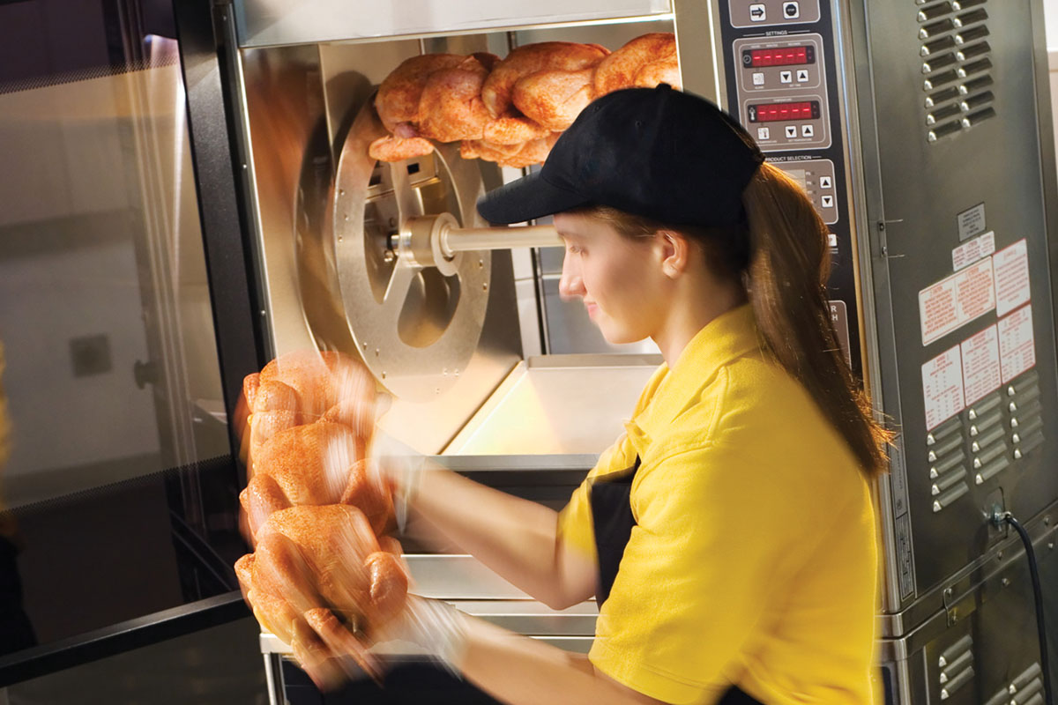 |  |  |  |  |  | - Heavy trays of food  - Slips and Trips  - Hot surfaces  - Hot objects
Procedure
Steps |  |  | Instructions
1  Plan the work |  |  |  |  | - Ensure the area you will work in is clear of hazards.  - Ensure you have the PPE (gloves apron, closed shoes) required for the job and you know how to wear it properly.  - If a shared pair of oven gloves is used. Team members should always wear clean, dry inner gloves when using.  - Ensure the stock you will handle is prepared for cooking and easy to move (on trays etc).
2  Conduct the work |  |  |  |  | - Wear your PPE when working with hot surfaces.  - Use good manual handling practices when loading ovens and cabinets, do not carry too much at a time.  - Keep in mind that surfaces are hot. A lapse in concentration may lead you to grab hot things.
3  Clean up |  |  |  |  | - Once you have finished the cooking or loading. Clean up the area and make it ready for the next job.  - Return the PPE to the storage location.  - Report any issues, including faults, incidents or hazards.
 | Training |  |  |  |  |  |  | trainee I acknowledge and understand the SWP and the training I have received.  Trainer: The trainee has been told and shown what a compliant standard looks like when conducting this task safely, the key risks have been emphasised, and the requirements of the process have been clearly communicated.
 | Trainee Name: |  |  |  |  |  |  | Trainee Signature: Payroll Number: Date:
 | Trainer Name: |  |  |  |  |  |  | Trainer Signature: Payroll Number: Date:
 | Trainer Name: |  |  |  |  |  |  | Trainer Signature: Payroll Number: Date:
 | Trainer Name: |  |  |  |  |  |  | Trainer Signature: Payroll Number: Date:
 | Trainer Name: |  |  |  |  |  |  | Trainer Signature: Payroll Number: Date:
 | Trainer Name: |  |  |  |  |  |  | Trainer Signature: Payroll Number: Date:

