Purpose: |  |  |  |  |  |  | To ensure the safe use of the Deli slicer.
Responsibilities: |  |  |  |  |  |  | All team members who use the meat slicer.
Personal Protective Equipment – As Required
  Safety Glasses |  |   ☑  Gloves |  |   ☑  Safety Footwear |  |  |  |   Ear plugs/Muffs |  |   Face shields |  |   ☑  High Visibility Vest/Clothing |   Safety Hat |   Safety Harness |   Protective Clothing |   Safety Mask |  |  | OTHER  Cold and Weather protection as required | NO PPE REQUIRED
Pre Start Checks |  |  |  |  |  |  |  |  |  |  |  |  |  |  |  |  | Potential Hazards
- Dressed appropriately for work with correct PPE  - Sensible closed shoes with rubber soles  - Non-Latex Gloves  - Work area clear to operate safely  - Floor clean and free of slippages  - Fit for work  - First aid kit on hand |  |  |  |  |  |  |  |  |  |  | 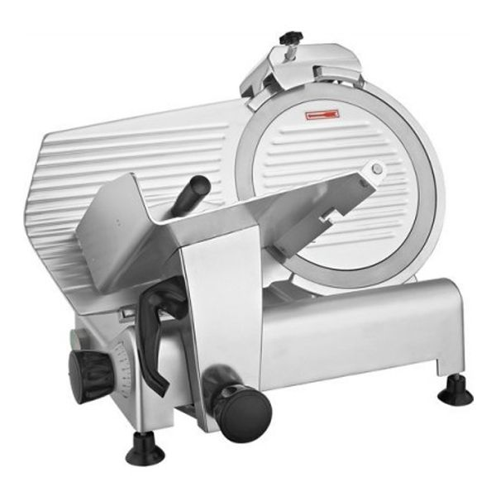 |  |  |  |  |  | - Sharp rotating blade  - Electricity  - Slips and Trips  - Heavy objects  - Cleaning/blockages
Procedure
Steps |  |  | Instructions
1  Plan the work |  |  |  |  | - DO NOT operate the machinery without training  - Ensure you are wearing any required PPE (gloves, apron, closed shoes).  - Check the meat slicer, ensure it is clean and operational with no blockages.  - Ensure any electrical leads are in good condition and not in a position to be cut or damaged.  - Ensure you have enough room for the products and trays or containers ready to receive the slices.
2  Conduct the work |  |  |  |  | - Use the meat slicer to slice the stock as required.  - Always use the meat holder/pusher to move the meat, never use your hands.  - Always keep your hands behind the guards and on the correct handles.  - DO NOT catch the slices with your hands  - Finish slicing the stock and remove the product and the waste from the slicer.  - Turn off the meat slicer when changing foods
3  Finish up |  |  |  |  | - Switch off the slicer at the machine switch and the wall. Unplug if you intend to wash the slicer down.  - Return the blade to zero to ensure the blade is aligned with the guard.
4  Dismantle and clean |  |  |  |  | - Turn the power off before cleaning  - Following manufacturer’s instructions, remove the parts of the slicer that require cleaning.  - Clean and sanitize slicing machine.  - With the Slicer, dismantle wash off all excess material and rinse with portable water . Wash with Microclean (1:50)  - Never sharpen a dirty blade  - Re-assemble the slicer.  - If faults or blockages cannot be removed Lock and Tag out slicer and report issue.
5  Check and finish |  |  |  |  | - Once the slicer is re-assembled, turn it on and check it is working and ready for the next job.  - If faults or blockages cannot be removed to Lock and Tag out slicer and report issue.  - Turn the slicer off.
 | Training |  |  |  |  |  |  |  | trainee I acknowledge and understand the SWP and the training I have received.  Trainer: The trainee has been told and shown what a compliant standard looks like when conducting this task safely, the key risks have been emphasised, and the requirements of the process have been clearly communicated.
 | Trainee Name: |  |  |  |  |  |  |  | Trainee Signature: Payroll Number: Date:
 | Trainer Name: |  |  |  |  |  |  |  | Trainer Signature: Payroll Number: Date:
 | Competency |  |  |  |  | trainee: I have the knowledge and skills to undertake this task confidently and safely.  Trainer: The trainee has demonstrated confidence, understanding and competency in conducting this task safely.  Training topics has included:  - Never put a hand behind the food chute guard.  - Never place food into the slicer by hand-feeding or hand pressure.  - Use a pushing/guarding device with chute-fed slicers.  - Use plungers to feed food into chute-fed slicers or use the feeding attachment located on the food holder.  - Turn off the food slicer when changing foods.  - Keep hands out of the danger zone on the back of the blade where the sliced food exits.  - Turn off and unplug slicers when not in use or when left unattended for any amount of time.
 | Trainee Name: |  |  |  |  |  |  |  |  |  |  | Trainee Signature: |  |  |  |  |  | Date:
 | Trainee Name: |  |  |  |  |  |  |  |  |  |  | Trainee Signature: |  |  |  |  |  | Date:
 | Trainee Name: |  |  |  |  |  |  |  |  |  |  | Trainee Signature: |  |  |  |  |  | Date:
 | Trainee Name: |  |  |  |  |  |  |  |  |  |  | Trainee Signature: |  |  |  |  |  | Date:
 | Trainee Name: |  |  |  |  |  |  |  |  |  |  | Trainee Signature: |  |  |  |  |  | Date:
 | Competent Person: |  |  |  |  |  |  |  |  |  |  | Competent Person Signature: |  |  |  |  |  | Date:

