Purpose: |  |  |  | Carry out manual handling tasks safely.
Responsibilities: |  |  |  | Team members and leaders engaged in manual handling tasks have responsibility to this procedure.
Personal Protective Equipment
  Safety Glasses  As required |  |   Gloves  As required |   Safety Footwear as required |  |   Ear plugs/Muffs |   Face shields |   High Visibility Vest/Clothing | Safety Hat | Safety Harness |  |  |   Protective Clothing |   Safety Mask | OTHER  Cold / Hot and Weather protection as required | NO PPE REQUIRED
Process Flow/Picture of Procedure |  |  |  |  |  |  |  |  |  |  | Potential Hazards  (what could cause an injury with performing the procedure)
 | Pre Start Checks:  - Check Footwear and clothing is appropriate.  - Ensure protective gloves are used when lifting objects with rough or sharp edges or surfaces  - Ensure sufficient persons are available for heavy, difficult or awkward lifts  - Never lift more than you are comfortably able to  - Use proper lifting techniques at all times  - Always check for loose objects prior to lifting an object  - Know the weight of any object to be manually lifted or moved  - Conduct Warm Ups prior to manual handling activities (start of the day) |  |  |  |  |  |  |  |  | - Heavy awkward objects  - Falling objects  - Slips and Trips  - Sharp edges

Procedure
1  Perform Pre Shift Warm Ups at the Start of Each Shift | March on the spot, increasing the height of your knees and swing your arms back and forth (30 Seconds) | 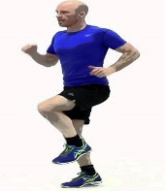 | Standing tall, reach your right arm across your chest. Use your left hand to push on the upper part of the right arm to bring it closer to your chest. Hold for 10 seconds. Repeat on other arm. |  | 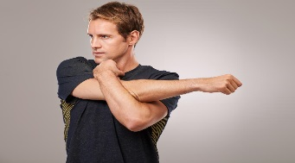
 | Extend your right arm straight out in front of your right shoulder with your fingers pointing upwards, your palm facing away. Use your left hand to gently pull the fingers of your right hand back towards you. Hold for 15 seconds. Repeat on other arm. | 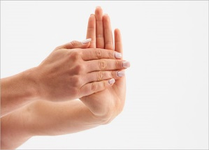 | Stand tall & square with arms by your side. Slowly roll shoulders backwards in small circles. Gradually make the circles bigger, incorporating your elbows, then build into full arm circles. (15 seconds) Repeat in the opposite direction (forwards). |  | 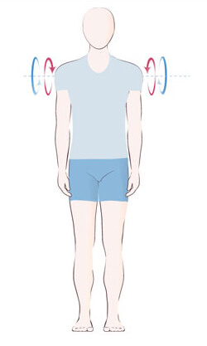
2  Prepare and plan for an object lift or move | - Check object for sharp / rough edges or surfaces, and use gloves when appropriate  - Decide on a path and a landing space, and clear path / landing space  - Use multiple personnel of similar build for moving heavy / awkward object  - Ensure commands for group lifts / moves (such as UP, DOWN, STOP, GO) are known and agreed prior to the task commencing  - Use lifting straps / kidney belts as required.
3  Move Object / Lift / Lower Object | - Use squat lift technique, with your leg muscles providing the overwhelming lift force  - Ensure balance is maintained by widening gap between feet if required, and do not balance on your toes  - Keep the centre of mass of yourself and the object in a straight line  - Ensure all staff are clear of object and landing space  - Avoid bending or rotating your back or using your arms to manoeuvre object. |  |  | 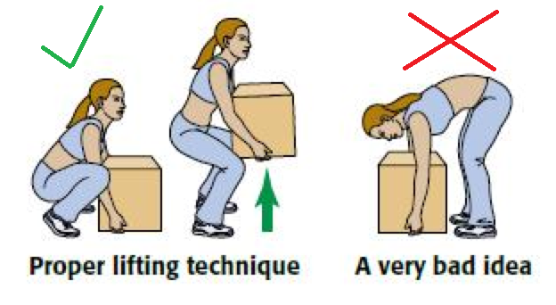
4  When using load shifting equipment or similar | - Ensure your stance is correct for the force to be applied to the tool or by the tool  - Change your weight distribution and foot position according to the load to be applied to the tooling or by the tooling  - Never over extend your reach or move your balance point to the point of a fall or impact  - Avoid rotating your back wherever possible |  |  | Use mechanical/lifting aids such as trolley or pallet jack if load is too heavy  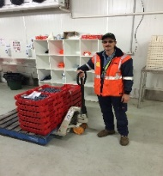

Training | trainee: I acknowledge and understand the SWP and the training I have received.  Trainer: The trainee has been told and shown what good looks like when conducting this task safely, the key risks have been emphasised, and the requirements of the process have been clearly communicated.
Trainee Name: |  | Trainee Signature: | Date:
Trainer Name: |  | Trainer Signature: | Date:
Trainee Name: |  | Trainee Signature: | Date:
Trainer Name: |  | Trainer Signature: | Date:
Trainee Name: |  | Trainee Signature: | Date:
Trainer Name: |  | Trainer Signature: | Date:

