Purpose: |  |  |  |  |  |  | To ensure all team members participate actively in good housekeeping practices.
Responsibilities: |  |  |  |  |  |  | All personnel
Personal Protective Equipment
  Safety Glasses |  |   ☑  Gloves |  |   ☑  Safety Footwear |  |  |  |   Ear plugs/Muffs |  |   Face shields |  |   High Visibility Vest/Clothing |   Safety Hat |   Safety Harness |   Protective Clothing |   Safety Mask |  |  | OTHER  Cold and Weather protection as required | NO PPE REQUIRED
Pre Start Checks |  |  |  |  |  |  |  |  |  |  |  |  |  |  |  |  | Potential Hazards
- Dressed appropriately for work with correct PPE  - Closed toed non slip shoes  - Gloves  - Fit for work  - First aid kit on hand |  |  |  |  |  |  |  |  |  |  | 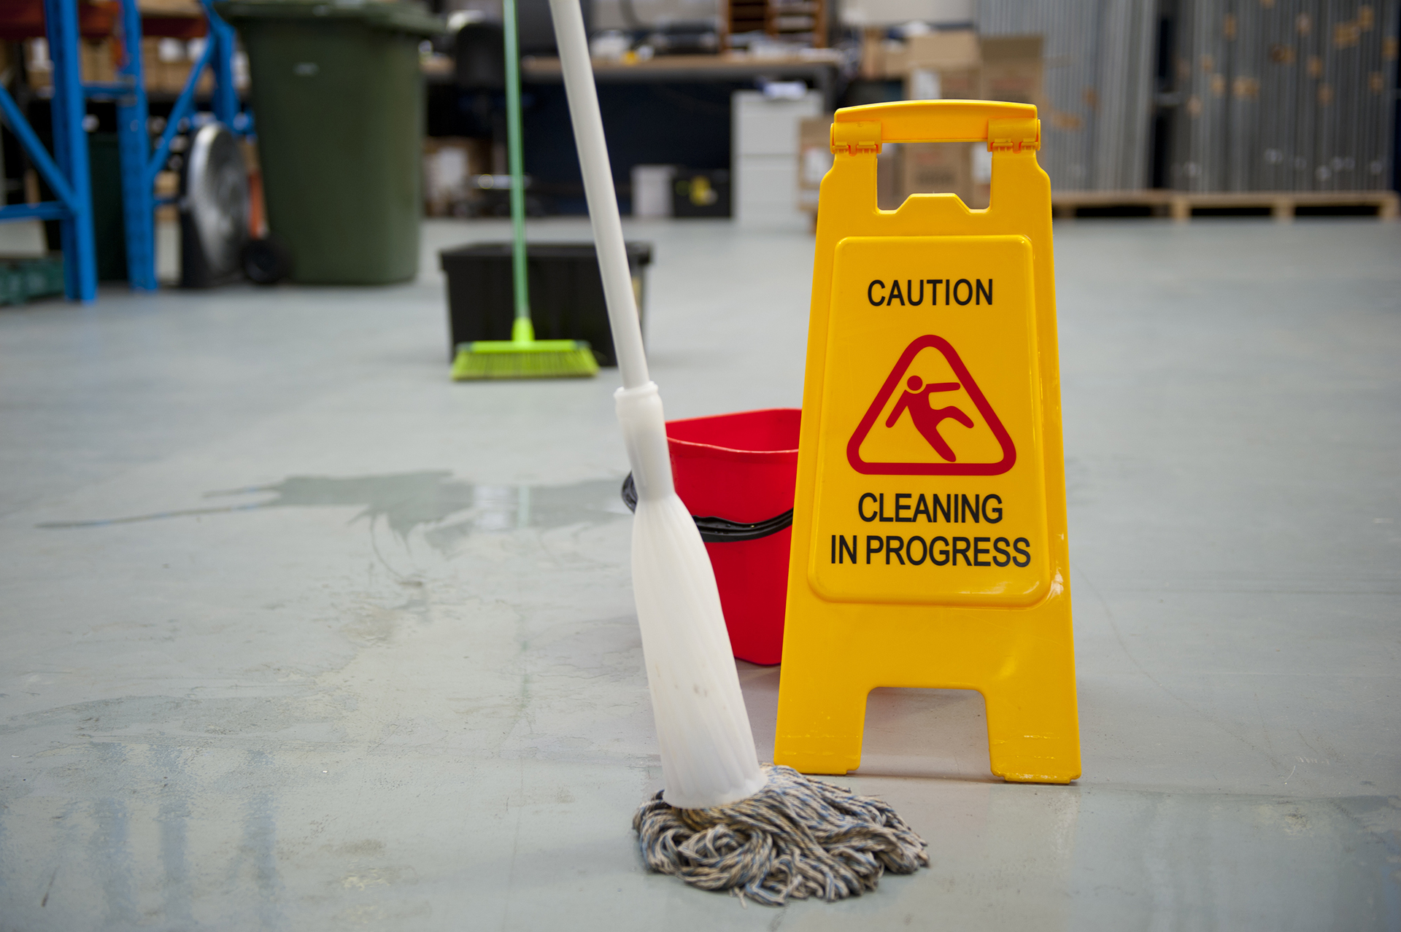 |  |  |  |  |  | - Manual handling  - Slip/Trip hazards  - Chemicals
Procedure
Steps |  |  | Instructions
1  Plan the work |  |  |  |  | - Ensure cleaning equipment is in good repair and ready for use at all times.  - Ensure you have safety barriers and signs ready for use when required.  - Ensure you have sufficient cleaning supplies for the work.  - Ensure bins are regularly emptied.
2  Maintain Housekeeping |  |  |  |  | - If you see an opportunity for housekeeping do not ignore it.  - If a housekeeping task is re-current, consider listing it as a hazard (a fridge that always drips water on the shop floor) to get a permanent fix.  - Keep an eye on problem areas prone to leakages such as the store refrigerators.
3  Safety Tips |  |  |  |  | - The standard you walk past is the standard you are prepared to accept.  - Housekeeping is always your job, no matter who made the mess, be the one to clean it up.  - Do not discount the value of being clean and tidy. Tidy workplaces are always safer.
 | Training |  |  |  |  |  |  |  | trainee I acknowledge and understand the SWP and the training I have received.  Trainer: The trainee has been told and shown what a compliant standard looks like when conducting this task safely, the key risks have been emphasised, and the requirements of the process have been clearly communicated.
 | Trainee Name: |  |  |  |  |  |  |  | Trainee Signature: Payroll Number: Date:
 | Trainer Name: |  |  |  |  |  |  |  | Trainer Signature: Payroll Number: Date:
 | Competency |  |  |  |  | trainee: I have the knowledge and skills to undertake this task confidently and safely.  Trainer: The trainee has demonstrated confidence, understanding and competency in conducting this task safely.
 | Trainee Name: |  |  |  |  |  |  |  |  |  |  | Trainee Signature: |  |  |  |  |  | Date:
 | Competent Person: |  |  |  |  |  |  |  |  |  |  | Competent Person Signature: |  |  |  |  |  | Date:

