Purpose: |  |  |  |  | To ensure the safe handling of chemicals commonly used in retail settings.
Responsibilities: |  |  |  |  | All personnel
Personal Protective Equipment
  ☑  Safety Glasses |   ☑  Gloves |  |   ☑  Safety Footwear |  |  |   Ear plugs/Muffs |   Face shields |  |   High Visibility Vest/Clothing |   Safety Hat |   Safety Harness |   Protective Clothing |   Safety Mask |  | OTHER  Cold and Weather protection as required | NO PPE REQUIRED
Pre Start Checks |  |  |  |  |  |  |  |  |  |  |  |  |  | Potential Hazards
- Dress appropriately for work with correct uniform  - Sensible closed, non slip shoes  - Gloves (suitable for chemicals)  - Safety Glasses  - Fit for work  - First aid kit on hand. |  |  |  |  |  |  |  | 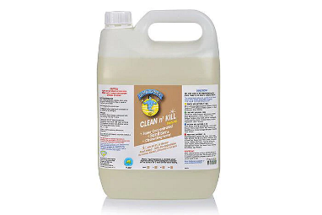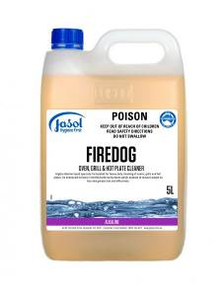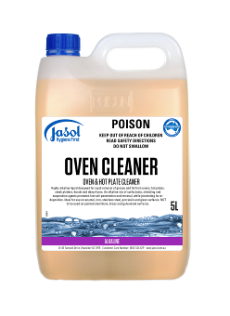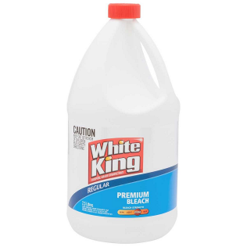 |  |  |  |  |  | - Manual handling  - Repetitive strains  - Trip hazards  - Chemicals
Procedure
Steps |  | Instructions
1  Plan the work |  |  |  | - Ensure you have a place to rinse hands, face and eyes if a splash occurs.  - Fit the required PPE and ensure the area you plan to work in is free from hazards.  - Ensure you have ready provisions for a spill. (spill kit or mop and bucket ready)  - Ensure you know which chemical to use for each particular task.  - Ensure you have sufficient chemical for the job, do not use more or less than specified by the manufacturer  - Mix only the quantity you need, unless otherwise instructed.
2  Conduct the work |  |  |  | - Use the chemicals required for the job in accordance with safety and manufacturer’s instructions.  - Clean up any excess chemicals as you go.
3  Clean up |  |  |  | - Once the task is complete, clean up and put away any left over chemicals.  - Ensure the area you worked in is safe for others (no spills or trip hazards).
4  Safety Tips |  |  |  | - Read the Safety Data Sheets to understand the chemical you are using.  - Ensure you understand the actions to take if a chemical is splashed or ingested.  - Do not keep more chemicals than you need, only order the minimum required.  - Ensure your safety data sheets are up to date (less than 5 years old).

Training | trainee I acknowledge and understand the SWP and the training I have received.  Trainer: The trainee has been told and shown what a compliant standard looks like when conducting this task safely, the key risks have been emphasised, and the requirements of the process have been clearly communicated.
Trainee Name: | Trainee Signature: Payroll Number: Date:
Trainer Name: | Trainer Signature: Payroll Number: Date:
Trainee Name: | Trainee Signature: Payroll Number: Date:
Trainer Name: | Trainer Signature: Payroll Number: Date:

