Purpose: |  |  |  |  | To ensure the safe handling and use of knives and blades.
Responsibilities: |  |  |  |  | All personnel using knives and box cutters
Personal Protective Equipment
  Safety Glasses |   ☑  Gloves |  |   ☑  Safety Footwear |  |  |   Ear plugs/Muffs |   Face shields |  |   High Visibility Vest/Clothing |   Safety Hat | 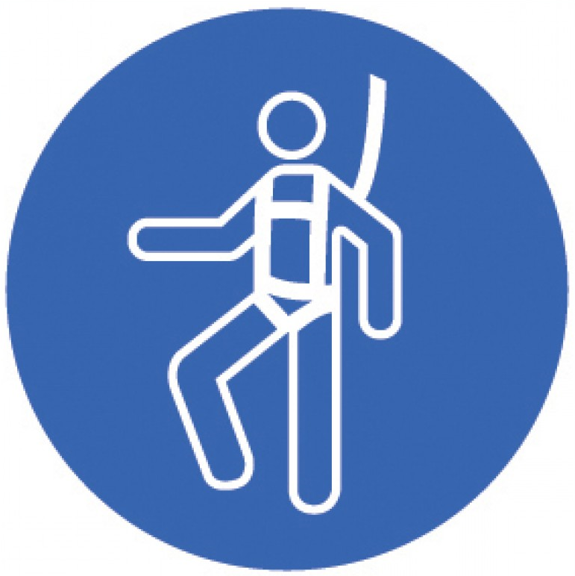  Safety Harness |   Protective Clothing | 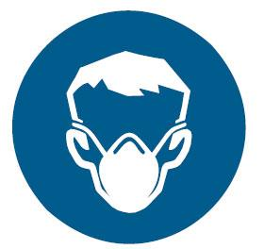  Safety Mask |  | ☑  OTHER  Cold and Weather protection as required | NO PPE REQUIRED
Pre-Start Checks |  |  |  |  |  |  |  |  |  |  |  |  |  | Potential Hazards
- Dress appropriately for work with correct uniform  - Sensible closed, non-slip shoes  - Cut resistant glove(s)  - Fit for work  - First aid kit on hand  - Current First Aider on site  - Knives are clean and sharp |  |  |  |  |  |  |  | 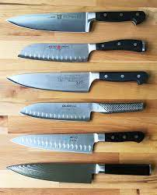 |  |  |  |  |  | - Manual handling  - Repetitive strains  - Sharp edges  - Dropped objects  - Trip hazards  - Other team members in close proximity
Procedure
Steps |  | Instructions
1  Plan the work |  |  |  | - Ensure the area in which you intend to use knives is clean, free of any electrical leads and has sufficient room for you to use the knives easily without being restricted in your movement.  - Ensure your knives are sharp. You should sharpen knives after every session of use and before storing them away.  - Choose the right knife for the job.  - Ensure you have a cut resistant glove(s) available if you choose to use them.  - Ensure a first aid kit is available and a current first aider is on site.
2  Setup the work area |  |  |  | - Prepare your chopping board (do not chop or slice on work surfaces)  - Ensure your chopping board is stable (a damp cloth under it can help)  - Ensure others know you are using knives in this area  - Check the items you intend to cut to ensure they are ready to be cut (remove wrapping etc)
3  Conduct the work |  |  |  | - Put on your cut resistant glove(s) You can wear nitrile rubber gloves under them if you wish.  - When using knives, always cut away from yourself and away from the hand you use to hold the item to be cut.  - Always carry the knife with the blade pointing to the floor.  - Use firm pressure on the item to be cut, do not apply force and if the knife is not cutting, STOP.
4  Clean up |  |  |  | - Once the cutting job is finished, begin to clean up.  - Put away the items you have cut first.  - When cleaning up the bench and board, clean the knife separately.  - DO NOT put knives in sinks of soapy water and leave them!  - Clean the knife, dry it and put it aside in a safe position ready to be sharpened.  - Finish cleaning your work area.
5  Sharpen the knives |  |  |  | - If you are competent at sharpening knives and your store has the equipment sharpen the knives.  - If you do not have the skills or equipment to sharpen the knives, take them to a professional regularly.
6  Store the knives |  |  |  | - Have a proper storing place for the knives. A knife block, rack or box. Storing sharp knives in drawers with other items can increase the likelihood of team members cutting themselves while reaching for them.
7  Safety Tips |  |  |  | - Never grab a falling knife, let it fall.  - Never hold a knife by the blade, always by the handle.  - Curl your knuckles when cutting so the ends of your off-hand fingers are not exposed.  - Never wash knives in boiling water as it can damage the steel.  - Never walk around with open knives. Take them in covers to the work area. Or leave them at the work area.

Training |  | trainee I acknowledge and understand the SWP and the training I have received.  Trainer: The trainee has been told and shown what a compliant standard looks like when conducting this task safely, the key risks have been emphasised, and the requirements of the process have been clearly communicated.
Trainee Name: |  | Trainee Signature: Payroll Number: Date:
Trainer Name: |  | Trainer Signature: Payroll Number: Date:
Competency | trainee: I have the knowledge and skills to undertake this task confidently and safely.  Trainer: The trainee has demonstrated confidence, understanding and competency in conducting this task safely.
Trainee Name: |  |  | Trainee Signature: | Date:
Competent Person: |  |  | Competent Person Signature: | Date:

