Purpose: |  |  |  |  | To ensure the safe operation and use of the (add model) Forklift at IGA xx
Responsibilities: |  |  |  |  | Licensed and authority to operate
Personal Protective Equipment
  Safety Glasses |   Gloves |  |   ☑  Safety Footwear |  |  |   Ear plugs/Muffs |   Face shields |  |   ☑  High Visibility Vest/Clothing |   Safety Hat | 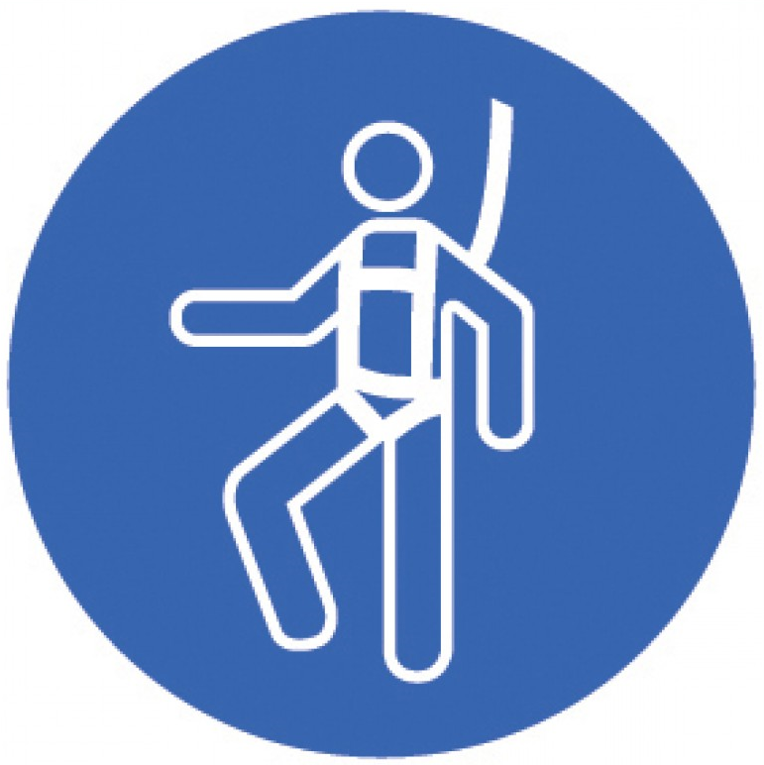  Safety Harness |   Protective Clothing |  |   Safety Mask | ☑  OTHER  Cold environment protection as required | NO PPE REQUIRED
Pre-Start Checks |  |  |  |  |  |  |  |  |  |  |  |  | Potential Hazards
- High Risk Work License (Code LF) *  - Completed IGA Competency process *  - Dressed appropriately for work with correct PPE and no loose clothing  - Australian standard safety boots  - Fit for work  - First aid kit on hand  - Forklift prestart completed  - Attachment points in good condition  - Battery Charged  - Work area ready, no spills and access clear to and from charging area.  * Mandatory requirements. DO NOT operate the Forklift without these controls in place. |  |  |  |  |  |  |  | Add picture of Forklift |  |  |  |  | - Manual handling/repetitive strains  - Unstable/overloaded loads  - Incorrect staking  - Objects fall off tynes  - Tip over due to sharp turning  - Tip forward due to travel with mast high  - Failure of plant resulting in loss of content, loss of load  - Damaged pallets/bins  - Poor visibility/ obstruction/ blind spots  - Travelling turning on gradients  - Forklift impact on structure  - Rain/spills/ causing slippery conditions  - Poor work methods/practices  - Battery explosion/Chemical burn  - Other vehicle traffic  - Untrained in safe work procedures  - Pedestrians/bystanders  - No license
Procedure
Steps |  | Instructions
1  Plan the work |  |  |  | - Ensure the pre-start checks listed above have been completed.  - Ensure the work area is in a suitable condition for the proposed tasks (see hazard list)  - Locate and ensure you are familiar with all machine operations and controls.
2  Operational condition checks |  |  |  | - Ensure the forklift pre-start inspection is completed and signed off by the Store Manager.  - Undertake your own checks before operation:  - Ensuring the forklift is on flat ground  - Inspecting the forklift’s body for damage and hydraulic for breakages and leaks  - Checking safety devices.  - Verifying that you have 360-degree visibility before operation  - Removing loose items from the forklift  - Finally, check the horn, steering, and brakes before operation.  - Record and report any faults to your Store Manager.  - Tag out for prohibited use if any safety features are non-functional.
3  Transporting Loads |  |  |  | - View the area and surrounding before moving off, ensure it is safe to commence work.  - While moving around the work area pay attention to team members on foot and ensure you know their positions (2 meters away from forklift).  - Ensure you follow the guidelines of signage for each work area.  - Ensure you reduce speed and sound horn when passing through doors and blind corners.  - Maintain speed limits depending on the environment and reduce speed when in doubt. Especially travelling through doors  - Carry loads at the lowest possible height to maximise stability. This must be 100mm or 10cm.  - Loads must not be more than a 3-bin or 15 pallets stack  - Ensure you use reverse travel when the load is tall enough to obscure forward vision.  - Reduce speed and acknowledge personnel via horn or communication when operating in the same area  - Ensure mast is slightly tilted back when carrying loads, this shifts centre of gravity to a more stable position.  - The horn must be sounded with 2 toots when approaching corners or blind corners as well as any blind spot where vision of intended path is obstructed.  - Do not lift loads over any person.  - Cease operation if persons on foot approaches the machine. Apply park position.
4  Shut down and park |  |  |  | - Once work is completed, return the forklift to the designated parking area.  - When parking  - Use the handbrake  - Lower forks to the ground  - Tilt so tips touch  - Remove key and return to office safe  - If any faults have been identified while working, record and report them.  - Tag out the machine for prohibited use if any faults are found with safety features.
5  Recharge |  |  |  | - Return the forklift to the recharging station.  - Parked position tynes tilted forwards  - Follow the charging SWP to correctly and safely recharge the machine.
Dos and Don’ts |  |  |  | - A forklift must not be used as a towing or push device, unless appropriate attachments are fitted  - A tow rope must never be attached to the mast to pull or drag loads  - The forklift must never travel with tynes raised or reach mechanism extended  - A person should not push on the point of one or both tynes. Nor should a person stand or walk under the elevated tynes, even when a load is not being carried  - A forklift must not lift loads greater than the capacity of the forklift  - A forklift must not lift a load that appears unsuitable or unstable (including on a damaged pallet/or bin)  - Don’t prematurely raise loads when approaching trucks, tailgates and racking  - Don’t turn whilst raising loads  - A forklift must not be parked on an incline or operated on gradients with the load elevated  - Do check over both shoulders before and whilst reversing  - Re-adjust speed when turning under load or otherwise must be safe and reasonable  - Make sure you understand the compliance plate of the forklift rating  - Forklifts must only be operated on IGA premises. Not on public roads with an exception noted for placing pallets on nature strip  - There must be a strictly enforced no Smoking Policy in battery charging area  - Naked flames should not be used when checking the level of electrolyte in battery cells.

Training |  | trainee I acknowledge and understand the SWP and the training I have received.  Trainer: The trainee has been told and shown what a compliant standard looks like when conducting this task safely, the key risks have been emphasised, and the requirements of the process have been clearly communicated.
Trainee Name: |  | Trainee Signature: Payroll Number: Date:
Trainer Name: |  | Trainer Signature: Payroll Number: Date:
Competency | trainee: I have the knowledge and skills to undertake this task confidently and safely.  Trainer: The trainee has demonstrated confidence, understanding and competency in conducting this task safely.
Trainee Name: |  |  | Trainee Signature: | Date:
Competent Person: |  |  | Competent Person Signature: | Date:

