**Grocery Manager (Worldsmart) – How to setup the IGA / The Mercury $30 Spend Offer**

These instructions will help you to setup the above promotion in a Grocery Manager (Worldsmart) back office. When this offer is triggered, the customer will receive a Mercury newspaper free if they spend at least $30 in the same purchase transaction.

To start, Grocery Manager > POS Communication > POS Utilities > Offer Management > Offer Maintenance

Then click “New Offer”

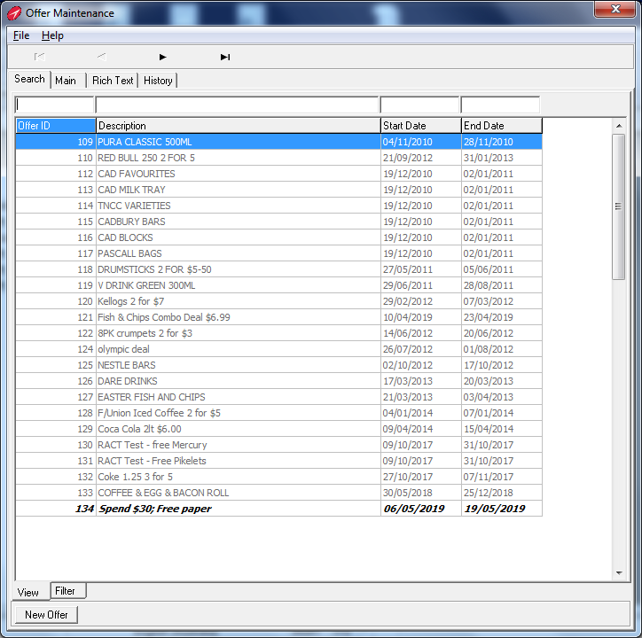

Enter Description and Start and End Date

Set Offer Type as “% Set Markdown”

Leave ither fields as their default setting

Click “OK” and save changes

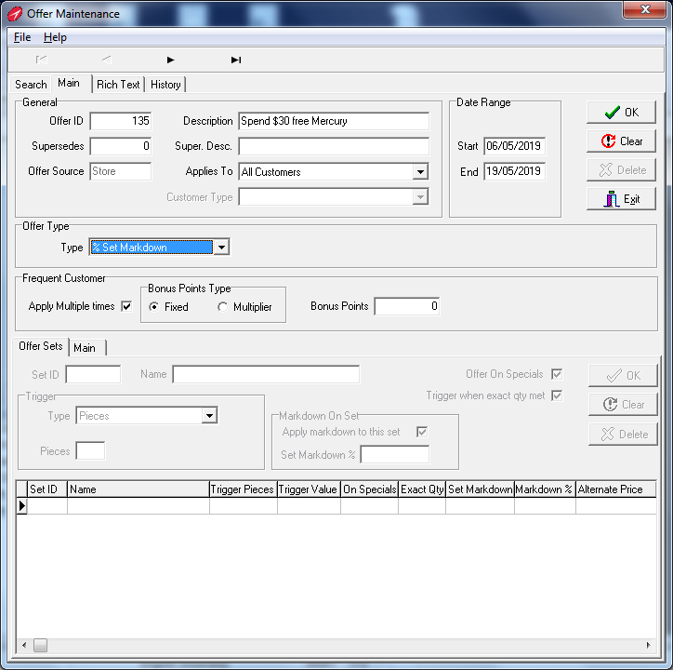

In the lower section of the screen, Click on the “Offer Sets” tab. You will setup two sets of products.

Create first set – enter “1” in Set ID field and add a description “Spend $30”

Trigger Type = “Price”

Price field = $30

Click “OK” and save changes

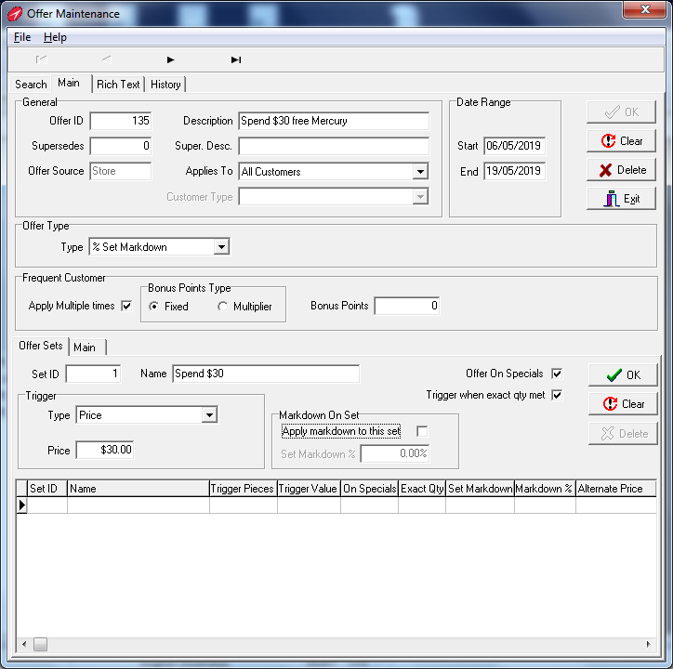

Create second set – enter “2” in Set ID and add a description “Free Mercury”

Trigger Type = “Pieces”

Pieces field = “1”

Tick “Apply Markdown to this Set”

Set Markdown % = 100%

Click “OK” and save changes

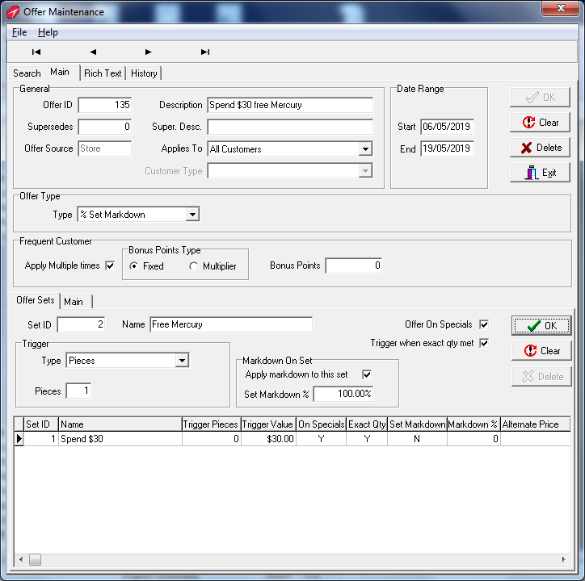

You are now ready to add the products or departments to each set.

Start with the first set by highlighting Set”ID 1 and click the “Main” tab

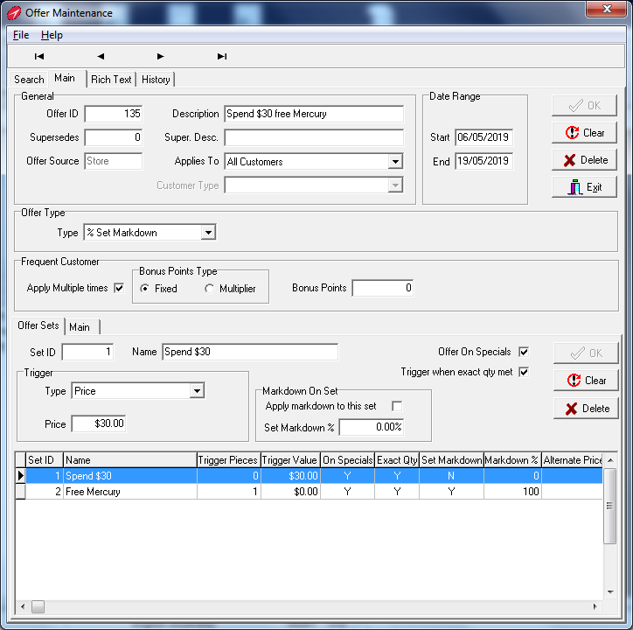

For this set you will select the departments that will be included in the $30 Spend.

Click the “Department” tab

Click on drop down box to select departments that are to be included in the Spend Amount

Repeat for each department to be included in the Spend amount and click “OK” each time.

Do NOT include Cigarette / Tobacco, Fuel, Pre-paid services (EG Aurora)

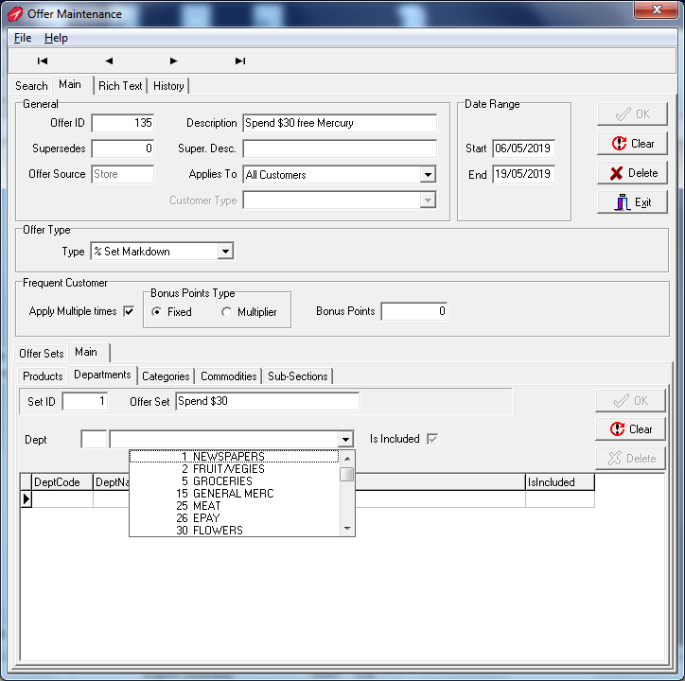

Repeat for each department to be included and click “OK” each time to build the list

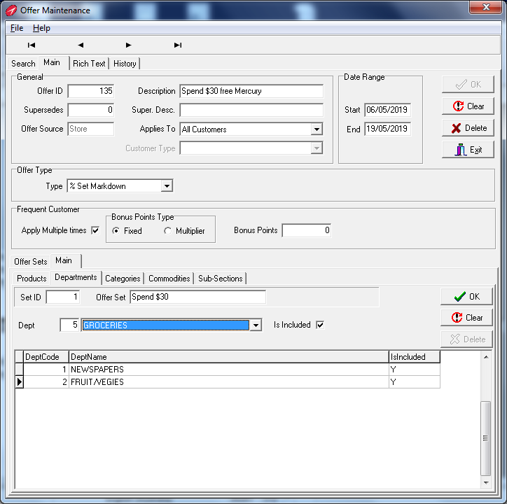

When the department list is complete, click the “Offer Sets” tab to work on the next set of products

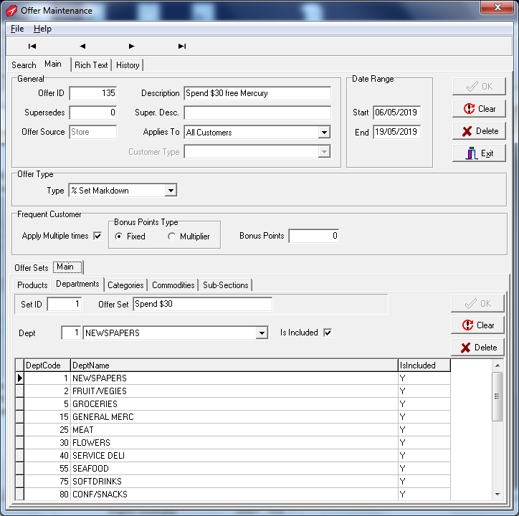

Now to add products to the second set – this will include each of The Mercury newspaper products.

Start by highlighting “Set ID 2” and click the “Main” tab

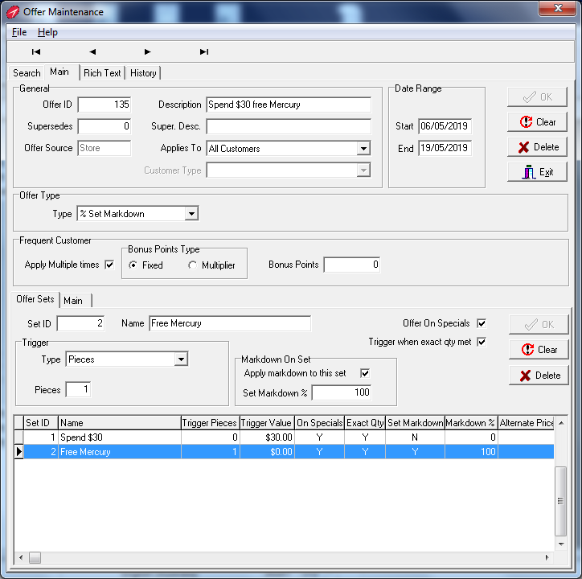

Then choose the “Products” tab

Then the “Search” tab below

Use the standard search functions to find each Mercury newspaper for each day of the week (including the Sunday Tasmanian). When found, double click the product to include in this set of products

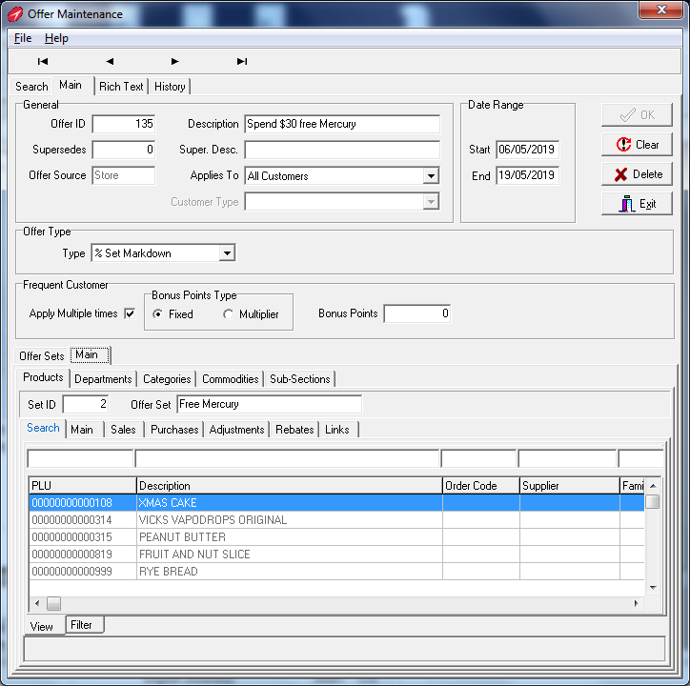

From the resulting screen (you’ve been moved to the Main tab now) click “OK” to confirm the product is to be added to the Free Mercury set of products.

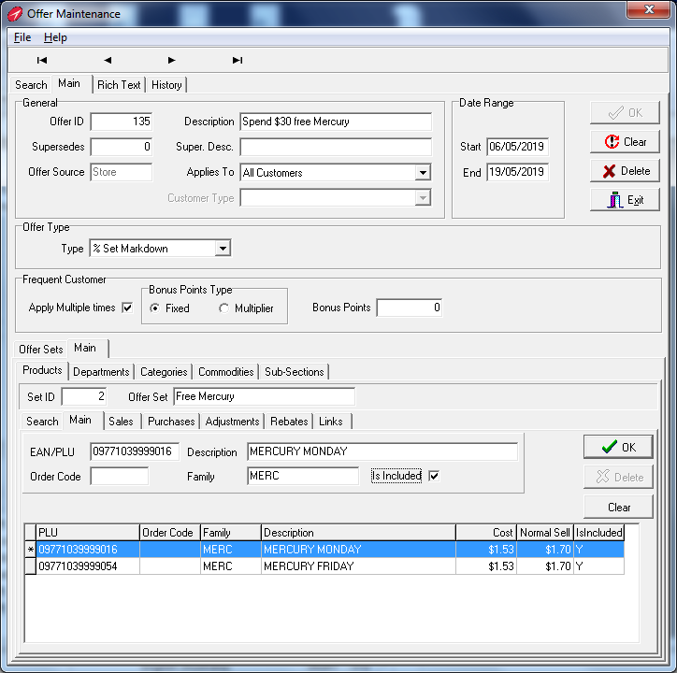

After confirming your selection you will be returned to the “Search” tab to find the next Mercury newspaper product. Repeat until all seven have been added to the selected list under the “Main” tab

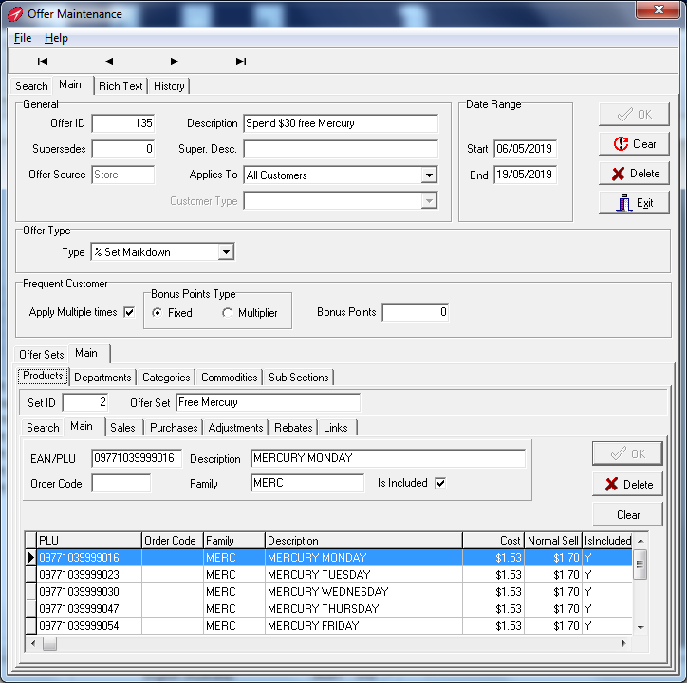

The Offer is now complete, click on “Exit” to return to the main Menu and send the Offer to the point of sale.

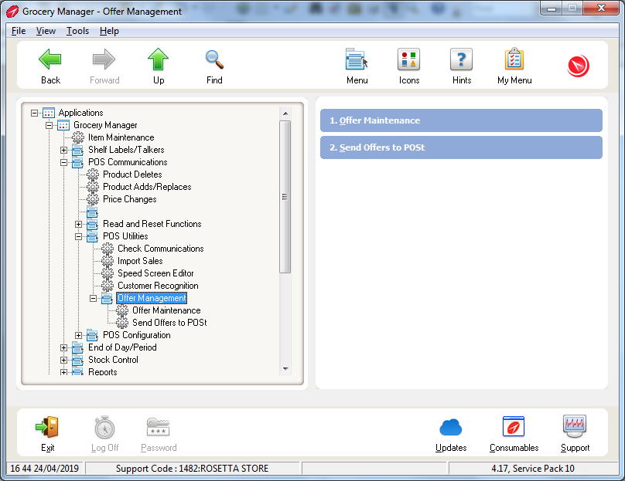

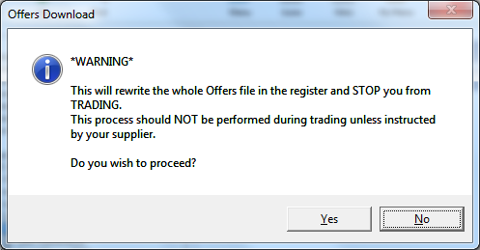

Please contact Chester Willcock (TIR) 0419 391 867) or Worldsmart Support, if you have any questions regarding this procedure

APRIL 2019