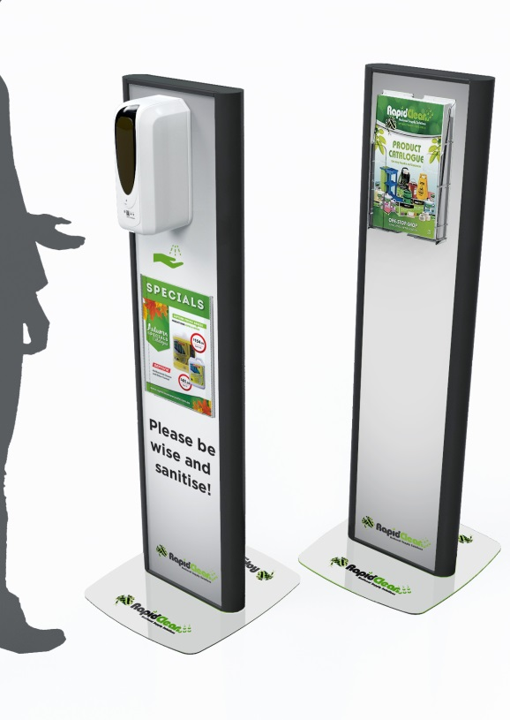**Please note: the stand does NOT come with any sanitiser. You will have to use your own or include sanitiser in this order.**

**Both sanitisers below are liquid (not gel) and both are effective in killing 99.9% of bacteria. Non-alcohol sanitiser may be more gentle on the hands!**

**Please complete the order form below and return to** [**craig.smith@igatas.com.au**](mailto:craig.smith@igatas.com.au) **or order by phone or email to your respective Area Manager.**

|  |  |
| --- | --- |
| **Store Name:** | **Store No:** |

|  |  |  |
| --- | --- | --- |
| **Description** | **Price** | **Quantity Req.** |
| Stand with refillable dispenser **with IGA Branding** | $299.00 |  |
| Stand with refillable dispenser (no branding) | $299.00 |  |
| Add A4 brochure holder with Clips | $19.95 |  |
| Add A4 sheet holder with Velcro tabs | $26.50 |  |
| Enzyme Wizard no alcohol hand sanitiser 5L | $72.50 |  |
| Enzyme Wizard no alcohol hand sanitiser 20L | $230.00 |  |
| Hand Sanitiser 80% Ethanol 5L | $95.50 |  |

**\*Prices exclude GST and freight**