**Profit Track – How to setup the IGA / The Mercury $30 Spend Offer**

These instructions will help you to setup the above promotion in a Profit Track back office.

When this offer is triggered, the customer will receive a Mercury newspaper free if they spend at least $30 in the same purchase transaction.

To start, select “Deals”, then click “Add”

Select “12. Buy Items from this set to receive a discount on items from that set”, then “Next”

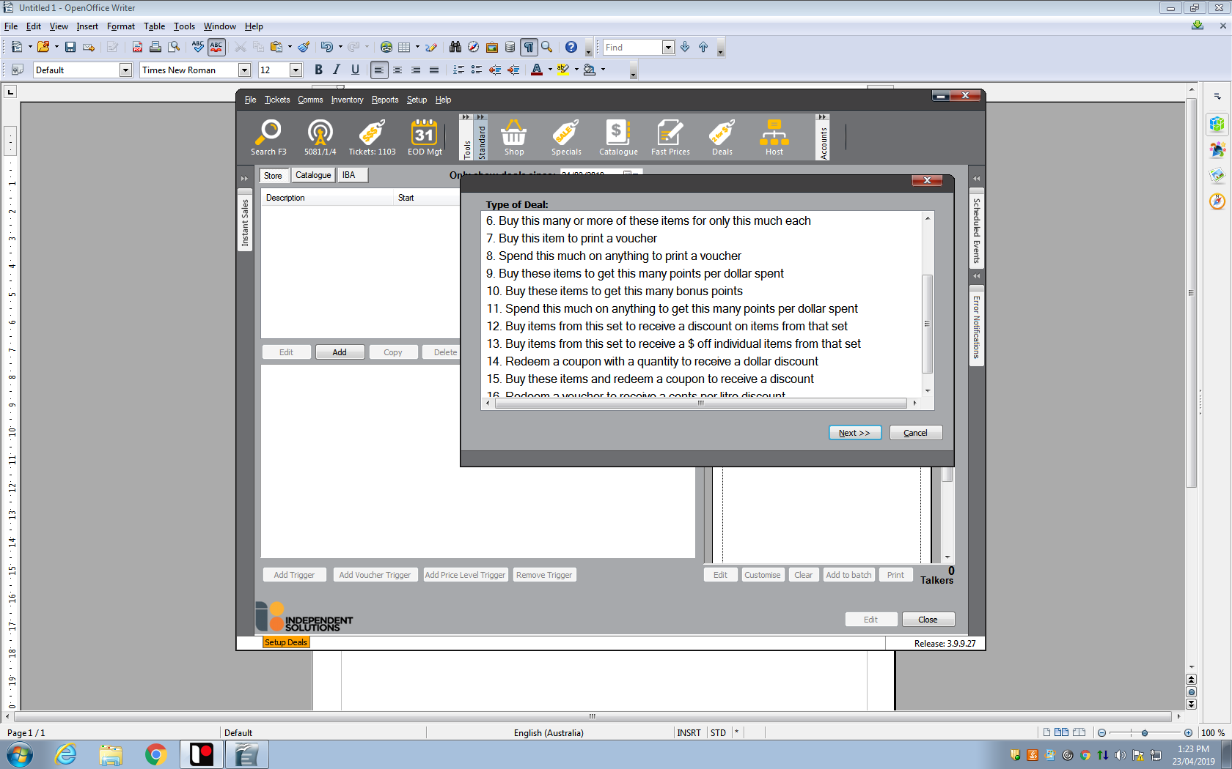

Type the deal description, set the start and end date for the promotion, click “OK”

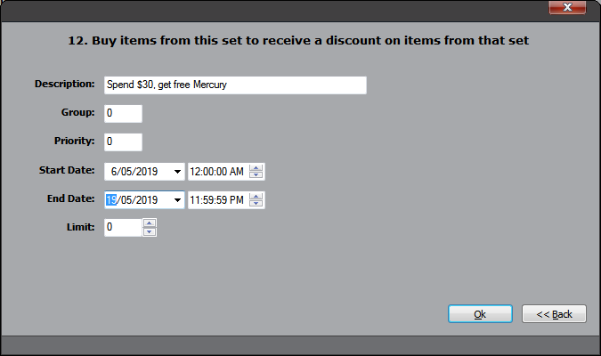

Click on “Buy 1” on the first line

Note: you may need to make a change to each link on this page. These instructions will repeat from this main screen stage until each link is set correctly.

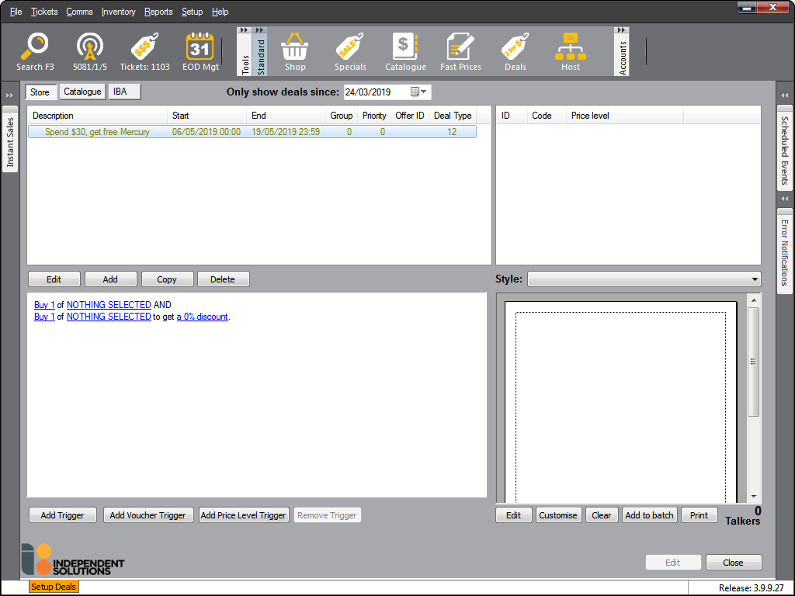

Change the Trigger Qty to “30.00”

Change the Trigger Type to “Value”

Tick the “Allow More” box

Then press “OK”

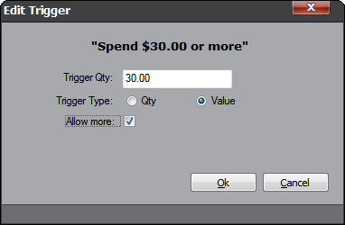

Repeat from the main screen by clicking “Nothing Selected” on the first line

On the resulting screen, (shown below)

Select the Department button

Tick “Everything Except” box

Select the departments that are excluded from the promotion (Tobacco, Fuel, Pre-paid services) – similar to diagram below, by highlighting the department in the ‘Available’ column and moving it to the ‘Selected’ column. You may need to include a different set of departments to the example shown)

Then click “OK”

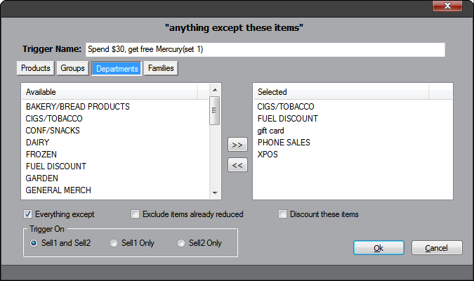

Repeat from the main screen by clicking “Nothing Selected” from the second line

Click “Add” and search for all the Mercury newspaper products, select them and add to the list until you have all variants of the Mercury in the list – one for each day

Ensure the “Discount these items” box is ticked, then click “OK”

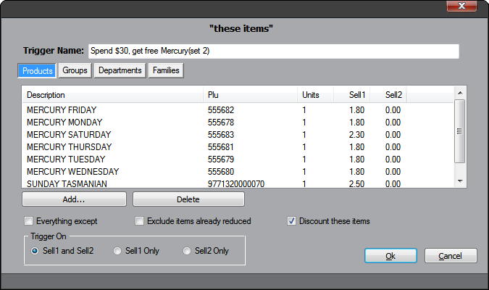

Repeat the ‘Add’ process until all 7 of The Mercury products are listed

Repeat from the main screen by clicking on “a 0% discount”

Change the discount amount to “100”, then click “OK”

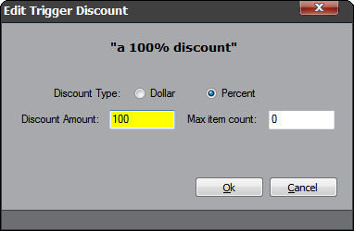

Click “save” in the bottom right corner to show the following deal

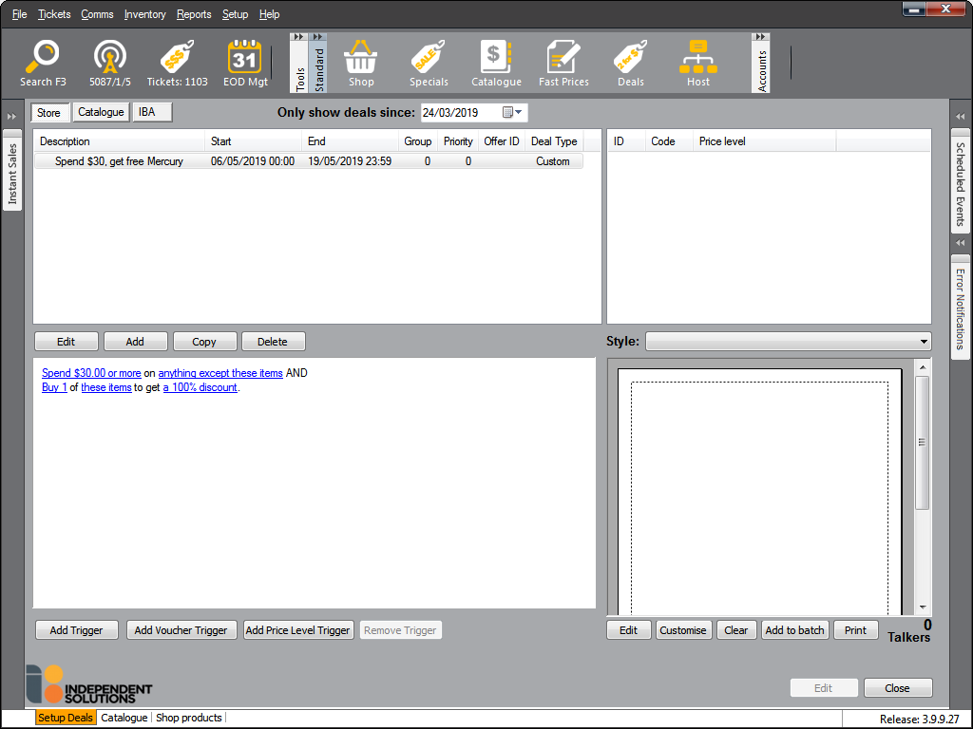

Upon exiting the screen, click “yes” to send the deal to your POS.

If you don’t send the Deal now it can be sent later by clicking on **Comms > Send Sundry Items > Send Deals**

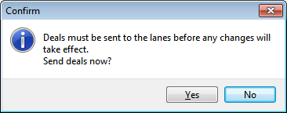

Contact Chester Willcock (TIR – 0419 391 867) or Independent Solutions Support if you have any questions about this offer.

April 2019