**Shop-Ezi (GaP Solutions) – How to setup the IGA / The Mercury $30 Spend Offer**

These instructions will help you setup the above promotion in a GaP Solutions (Shop Ezi) back office. When this offer is triggered, the customer will receive a Mercury newspaper free if they spend at least $30 in the same purchase transaction.

To start, Select Deal Wizard

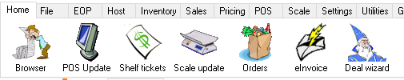

When the Deal Wizard Dialogue comes up select the ADD function

Give the Deal a name and select your start and end dates – then select NEXT

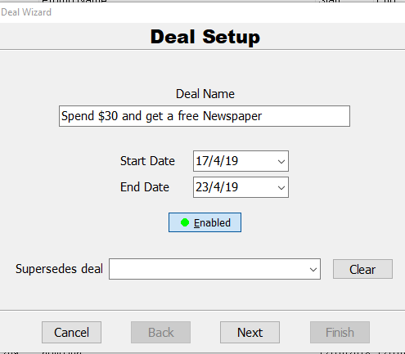

In Trigger Conditions select Add > select Total > Select Next

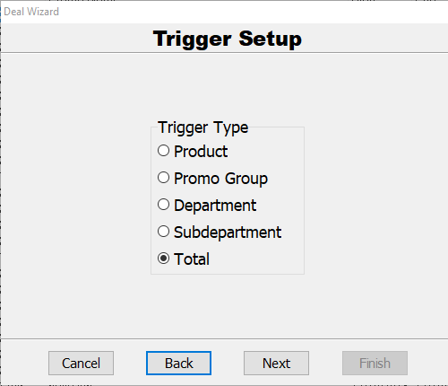

Trigger Amount = 29.99 select Next and Next again

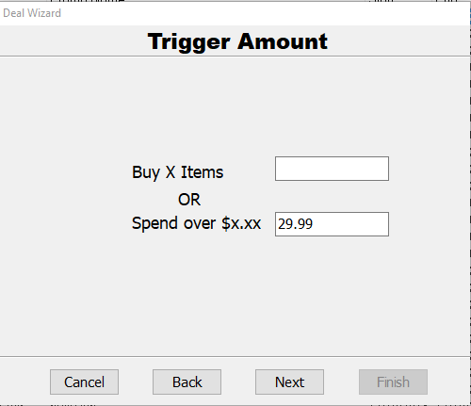

Select “Free Product – if bought with Triggers”

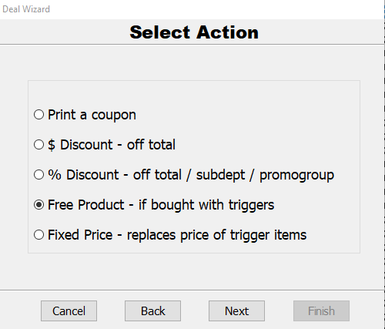

Find the Mercury Newspaper by selecting Search or type in the APN or Item number (I don’t have this on my system so the example below has the Australian) and repeat for each weekday and weekend Mercury.

> select Next

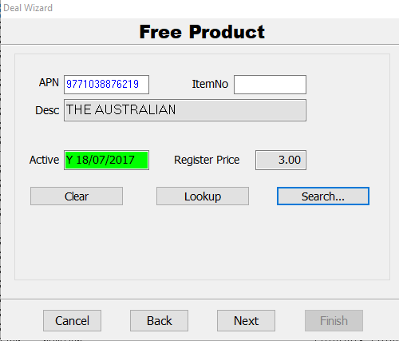

Select Next > Select Finish

It is common that Tobacco, Fuel and Pre-Paid services departments are already excluded from any Deals. However, if you want to verify the departments that are excluded from Deals, check the following setting in Settings > Department Maintenance (as highlighted)

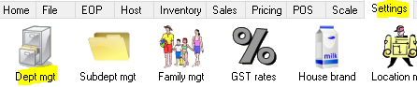

The example below shows the Tobacco Department has been excluded from Deals. check the highlighted flag is set

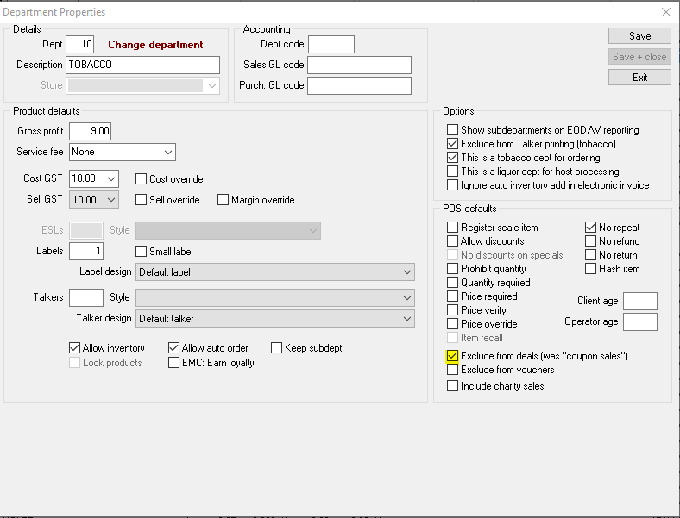

Please contact Chester Willcock (TIR 0419 391 867) or GaP Solutions Support, if you have any questions.

April 2019