

**New Product Offer**

Tas Coffee Roasters Filter/French Press is a freshly ground, organically certified product.

Available in 250gm packs of 8

Price $8.00 per unit RRP $12.00

Our Ground Coffee Range:

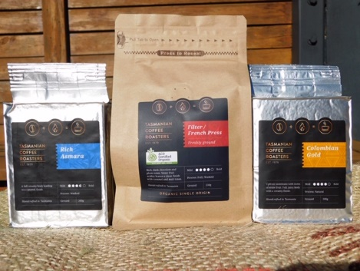

Introductory Offer

$7.50 per unit

Minimum order 8 units

Available for TIR Charge Through Customers only