

Shopping Trolley Wipe Units March 2020
16 Brett Drive, Carrum Downs Vic. 3201

Order Form- CitrusWirx™ Anti Bacterial Trolley Wipes

Item # | Description |  | Carton Specifications |  | Order Qty |  | Qty Req. |  | Price  Excl GST |  | Total  Incl GST
C46S |  | Citrus Wirx-460 Wipes/roll |  | Qty: 12 per carton  Weight: 19kg  Size of carton:  360 (w) x 420 (L) x 340 (h) |  | 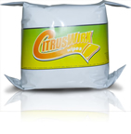  12 Rolls supplied with order. |  |  |  | $25.00 per roll |  | $330.00
C003 |  | CitrusWirx wall Mount Dispenser |  | Qty: 1 per carton  Weight: 1 kg  Size of carton:  300 (w) x 250 (L) x 300 (h) |  | 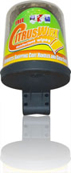 |  |  |  | $88.00 |  | $96.80
C005 | Sanitation Wipe Sign. Custom Signs on request. |  | 1 per carton  Weight:2Kg  Size of carton:  25 (w) x 400 (L) x 700 (h) |  | 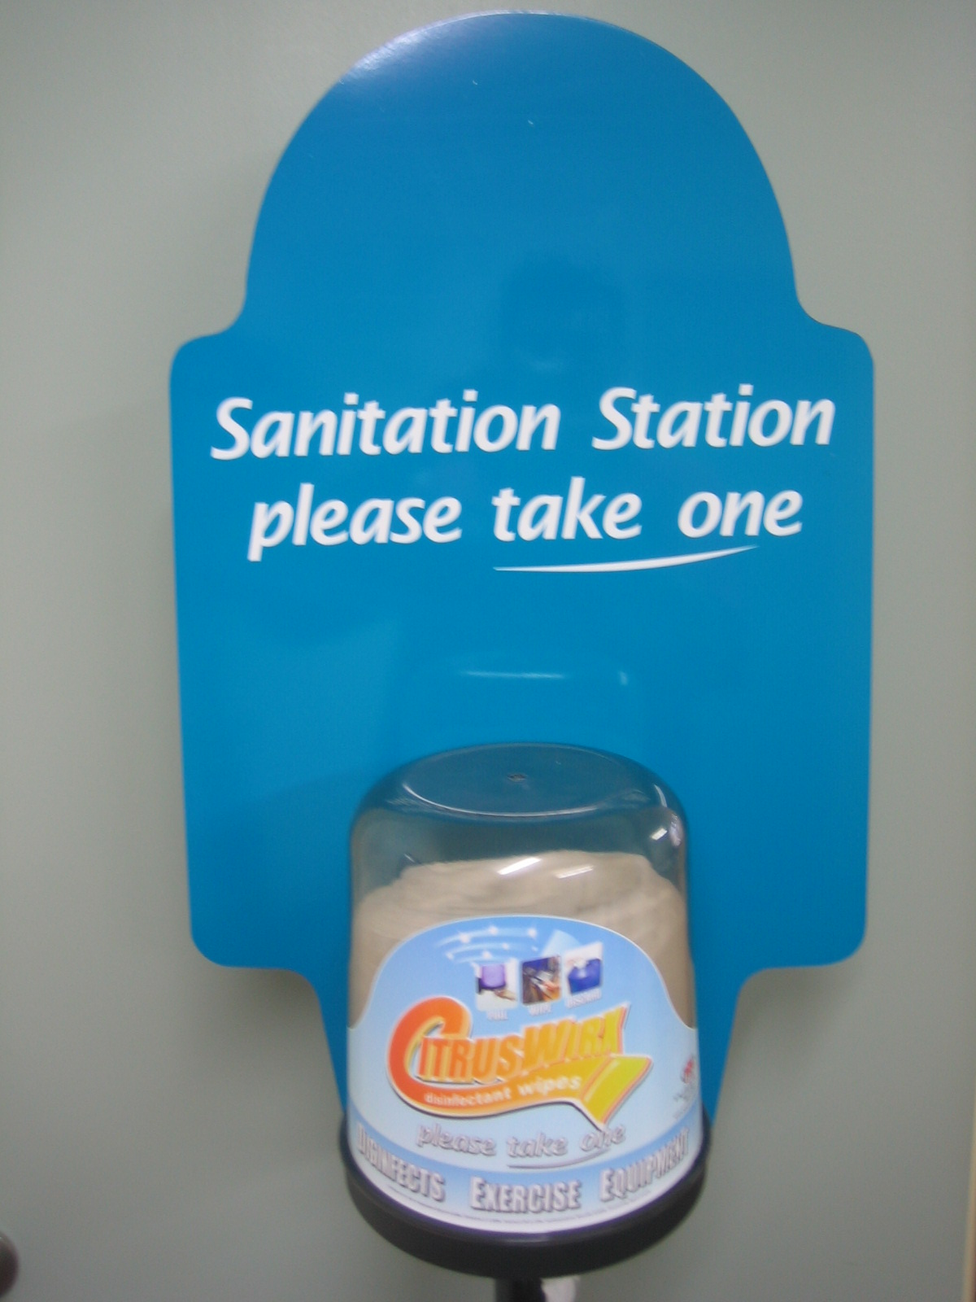 |  |  |  | $116.00 |  | $127.60
C014 | Floor Stand / Dispenser / Bin |  | 1 per carton  Weight: 14Kg  Size of carton: 310 (w) x 310 (L) x 1340 (h) |  | 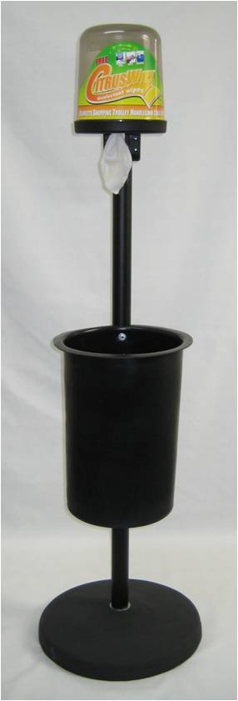 |  |  |  | $325.00 |  | $357.50

Prices are subject to 10% GST. Freight is charged at cost and itemised separately on the invoice and to be sourced at time of delivery.

Ship To: Payment Method - Charge Through #
Address:
Suburb: State Post Code
Contact: Phone

Send Order Form to your area manager or Email craig.smith@igatas.com.au.
(Stands can be ordered without the sign).

