**$25.00 Including GST**

**Red Men’s & Ladies**

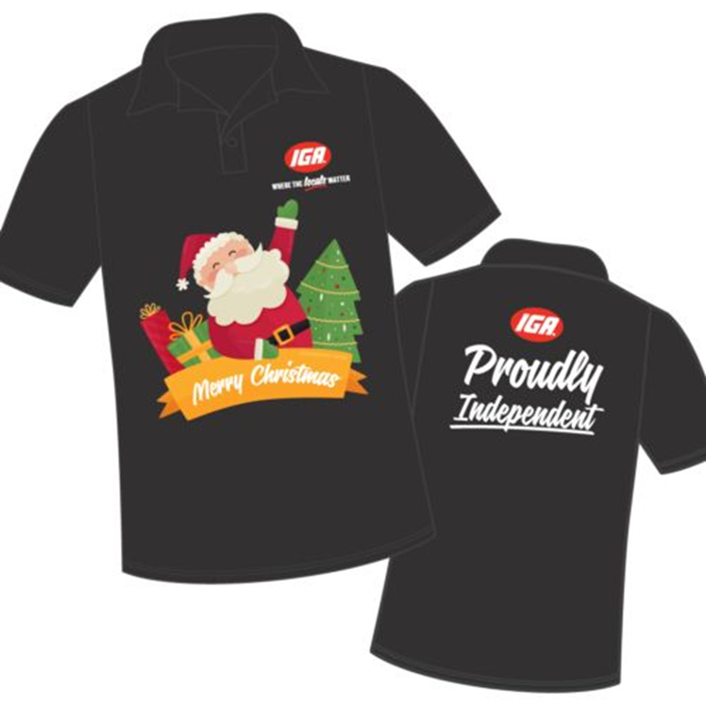**Short Sleeve Polos Only**

**$25.00 Including GST**

**Black Men’s & Ladies**

**Short Sleeve Polos Only**

**Christmas Polo Pre – Orders are Open Now**

**Cut off Date – Orders must be placed online by COB Wednesday 17th August**

**NO EXCEPTIONS**

**Dispatch to stores is expected to be early November.**

**Strictly NO Returns or Exchanges on Christmas Polos**

**Christmas Polos Must be order seperatly ond cannot be combined with any other items.**

* **Freight Charges apply for orders UNDER $300 + GST**
* **FIS (Free-into-store) for orders ABOVE $300 + GST**
* **TIR will be consolidating all orders to make sure we make sure all orders do not have and freight applied.**

**Mens Christmas Polo – Red**

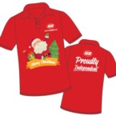 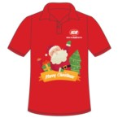 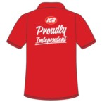

**Fabric: Polyester Colour: Red Decoration: Custom Design**

**Description: Lightweight, Comfortable, Regular fit**

**SIZE CHART Men’s Christmas Polo**

**Size chart is approximate and to be used as a guide only.**

**SIZE XS S M L XL 2XL 3XL 5XL**

**Half Chest (cm) 51.5 54 56.5 59 61.5 64 66.5 71.5**

**Centre Back Length(cm) 67 69 71 73 75 77 79 83**

**Christmas Polo Pre – Orders are Open Now**

**Cut off Date – Orders must be placed online by COB Wednesday 17th August**

**NO EXCEPTIONS**

**Dispatch to stores is expected to be early November.**

**Strictly NO Returns or Exchanges on Christmas Polos**

**Christmas Polos Must be order seperatly ond cannot be combined with any other items.**

* **Freight Charges apply for orders UNDER $300 + GST**
* **FIS (Free-into-store) for orders ABOVE $300 + GST**
* **TIR will be consolidating all orders to make sure we make sure all orders do not have and freight applied.**

**Mens Christmas Polo – Black**

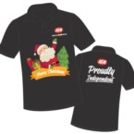 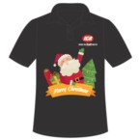 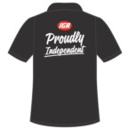

**Fabric: Polyester Colour: Black Decoration: Custom Design**

**Description: Lightweight, Comfortable, Regular fit**

**PLEASE NOTE: No returns or exchanges on Christmas Polos,**

**SIZE CHART Men’s Christmas Polo**

**Size chart is approximate and to be used as a guide only.**

**SIZE XS S M L XL 2XL 3XL 5XL**

**Half Chest (cm) 51.5 54 56.5 59 61.5 64 66.5 71.5**

**Centre Back Length(cm) 67 69 71 73 75 77 79 83**

**Christmas Polo Pre – Orders are Open Now**

**Cut off Date – Orders must be placed online by COB Wednesday 17th August**

**NO EXCEPTIONS**

**Dispatch to stores is expected to be early November.**

**Strictly NO Returns or Exchanges on Christmas Polos**

**Christmas Polos Must be order seperatly ond cannot be combined with any other items.**

* **Freight Charges apply for orders UNDER $300 + GST**
* **FIS (Free-into-store) for orders ABOVE $300 + GST**
* **TIR will be consolidating all orders to make sure we make sure all orders do not have and freight applied.**

**Ladies Christmas Polo – Red**



**Fabric: Polyester Colour: Red Decoration: Custom Design**

**Description: Lightweight, Comfortable, Regular fit**

**SIZE CHART Men’s Christmas Polo**

**Size chart is approximate and to be used as a guide only.**

**SIZE 8 10 12 14 16 18 20 22 24 26**

**Half Chest (cm) 48 50 52 54 57 60 62 65 68 71**

**Centre Back Length(cm) 64 65 66 67 68 69 71 72 74 75**

**Christmas Polo Pre – Orders are Open Now**

**Cut off Date – Orders must be placed online by COB Wednesday 17th August**

**NO EXCEPTIONS**

**Dispatch to stores is expected to be early November.**

**Strictly NO Returns or Exchanges on Christmas Polos**

**Christmas Polos Must be order seperatly ond cannot be combined with any other items.**

* **Freight Charges apply for orders UNDER $300 + GST**
* **FIS (Free-into-store) for orders ABOVE $300 + GST**
* **TIR will be consolidating all orders to make sure we make sure all orders do not have and freight applied.**

**Ladies Christmas Polo – Red**



**Fabric: Polyester Colour: Black Decoration: Custom Design**

**Description: Lightweight, Comfortable, Regular fit**

**SIZE CHART Men’s Christmas Polo**

**Size chart is approximate and to be used as a guide only.**

**SIZE 8 10 12 14 16 18 20 22 24 26**

**Half Chest (cm) 48 50 52 54 57 60 62 65 68 71**

**Centre Back Length(cm) 64 65 66 67 68 69 71 72 74 75**

**Christmas Polo Pre – Orders are Open Now**

**Cut off Date – Orders must be placed online by COB Wednesday 17th August**

**NO EXCEPTIONS**

**Dispatch to stores is expected to be early November.**

**Strictly NO Returns or Exchanges on Christmas Polos**

**Christmas Polos Must be order seperatly ond cannot be combined with any other items.**

* **Freight Charges apply for orders UNDER $300 + GST**
* **FIS (Free-into-store) for orders ABOVE $300 + GST**
* **TIR will be consolidating all orders to make sure we make sure all orders do not have and freight applied.**

**CHRISTMAS POLO SHIRT ORDER SHEET**

|  |  |  |
| --- | --- | --- |
| **Store Number:** | **Store Name:** | **Date:** |

|  |  |
| --- | --- |
| **Ordered By:** |  |

**Christmas Polo Pre – Orders are Open Now**

**Cut off Date – Orders must be placed online by COB Wednesday 17th August**

**NO EXCEPTIONS**

**Dispatch to stores is expected to be early November.**

**Strictly NO Returns or Exchanges on Christmas Polos!!**

|  |  |  |  |  |  |  |  |  |  |  |  |
| --- | --- | --- | --- | --- | --- | --- | --- | --- | --- | --- | --- |
| **MENS RED CHRISTMAS POLO SHIRTS** | | | | | | | | | | | |
| **XS** | **S** | **M** | **L** | **XL** | **2XL** | **3XL** | **5XL** |  |  |  |  |
|  |  |  |  |  |  |  |  |  |  |  |  |

|  |  |  |  |  |  |  |  |  |  |  |  |
| --- | --- | --- | --- | --- | --- | --- | --- | --- | --- | --- | --- |
| **MENS BLACK CHRISTMAS POLO SHIRTS** | | | | | | | | | | | |
| **XS** | **S** | **M** | **L** | **XL** | **2XL** | **3XL** | **5XL** |  |  |  |  |
|  |  |  |  |  |  |  |  |  |  |  |  |

|  |  |  |  |  |  |  |  |  |  |  |  |
| --- | --- | --- | --- | --- | --- | --- | --- | --- | --- | --- | --- |
| **LADIES RED CHRISTMAS POLO SHIRTS** | | | | | | | | | | | |
| **8** | **10** | **12** | **14** | **16** | **18** | **20** | **22** | **24** | **26** |  |  |
|  |  |  |  |  |  |  |  |  |  |  |  |

|  |  |  |  |  |  |  |  |  |  |  |  |
| --- | --- | --- | --- | --- | --- | --- | --- | --- | --- | --- | --- |
| **LADIES BLACK CHRISTMAS POLO SHIRTS** | | | | | | | | | | | |
| **8** | **10** | **12** | **14** | **16** | **18** | **20** | **22** | **24** | **26** |  |  |
|  |  |  |  |  |  |  |  |  |  |  |  |

|  |  |  |  |  |  |  |  |  |  |  |  |
| --- | --- | --- | --- | --- | --- | --- | --- | --- | --- | --- | --- |
| **TIR CONSOLADATED ORDER** | | | | | | | | | | | |
| **XS** | **S** | **M** | **L** | **XL** | **2XL** | **3XL** | **5XL** |  |  | **Total** |  |
|  |  |  |  |  |  |  |  |  |  |  |  |
| **8** | **10** | **12** | **14** | **16** | **18** | **20** | **22** | **24** | **26** | **Total** |  |
|  |  |  |  |  |  |  |  |  |  |  |  |