Risk Assessment Name:
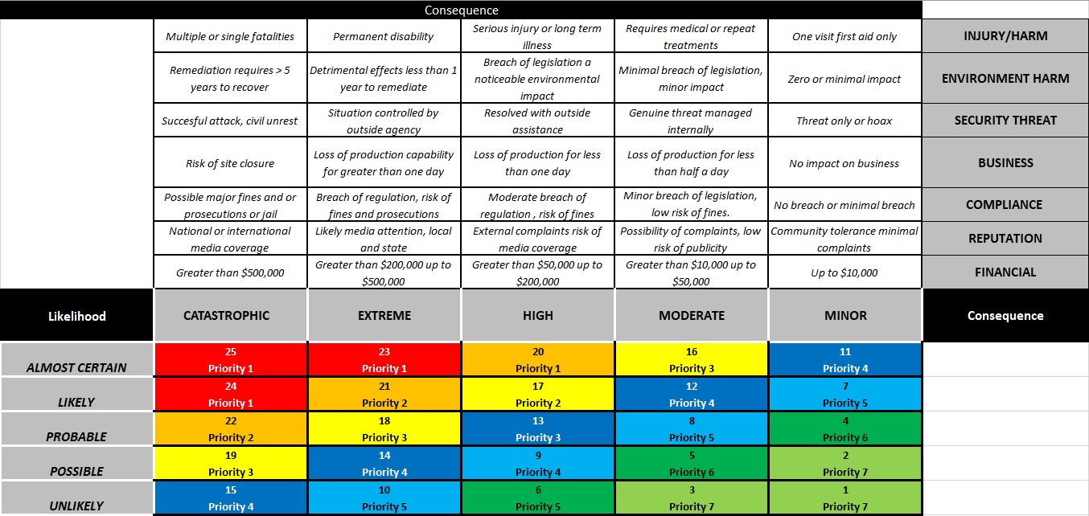
Less desirable
More desirable
Hierarchy of Control
Eliminate - Remove the hazard
Substitute – Replace the hazard with a lower risk option.
Isolate – Keep the hazard separate from the team members.
Engineering – Use guards or physical controls to protect the team members.
Administrative – Introduce rules, training, guidelines or similar to increase competence and awareness of the hazard and it’s risks.
PPE – Provide suitable personal protective equipment that is effective in reducing the risks and outcomes of the hazard.

What are the hazards? | Who might be harmed and how? | Initial risk rating (without controls) | What are you already doing to control the risks? | Residual risk rating (with controls) | What further action do you need to take to control the risks? | Who needs to carry out the action? | When is the action needed by? | Done

Any Licences, Training required?

Who Developed This Risk Assessment
Team Member Name | Team Member Position | Date | Signature

