Slips and Trips Mapping Tool
How to use the mapping tool
- Draw a sketch map of the area. The examples on page 2 show how the risk mapping tool works (the map does not need to be a work of art or even to scale, as long as it represents the workplace affected).
- Mark all the slips and trips reported in the last 12 months (or any relevant period) with crosses on the map.
- Talk to members to identify any ‘near misses’ and add them to the map.
- Find out from members what is causing people to slip or trip in that area. Any ‘hotspots’ will quickly show up on the map. Once you have identified the problems and their causes:

- discuss them with management
- decide what action needs to be taken
- continue to monitor to ensure control measures put in place are working
- make sure improvements are communicated to members.

Checklist for Health and Safety representatives
Health and safety inspectors focus on incidents where there is a significant risk of injury from a slip or trip. A safety representative, using the same approach, can decide whether there is a significant risk by:
- looking at the work in progress and discussing other tasks, eg goods receipt and dispatch, maintenance, cleaning etc to identify where potential risks are/could be present;
- spotting leaking plant or machinery with fluids accumulating on floors;
- seeing the build-up of contamination on the floor, with no visible sign of containment or clean-up, eg brought in on footwear in wet weather;
- noticing the use of ad hoc measures to control leaks, such as corrugated cardboard being put down or warning signs left in place for extended periods;
- considering the age and construction of buildings, whether there is evidence of leaking roofs, walkways exposed to the elements and potential for water, mud etc, to be brought into the workroom on wet clothing, shoes or vehicles;
- seeing cluttered walkways, build-up of waste materials, general untidiness, impeded pedestrian access, trailing cables etc;
- talking to staff to identify ‘difficult jobs’ or hearing about incidences of falls not leading to injury (‘near misses’);
- examining records for evidence of slip and trip problems – in incident register.

Example of Mapped Area of a Food Factory:
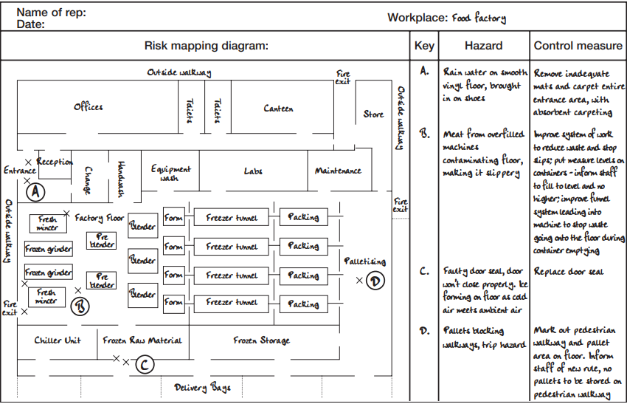
<Use this template to map and record your slip and trip risk areas>
Name of health and safety rep:
Date:
Risk Mapping diagram | Key | Hazard | Control measures

