Risk Assessment Name: Superfast Store Assessment: Date 1 Jan 2022 Completed by: Mel Axford
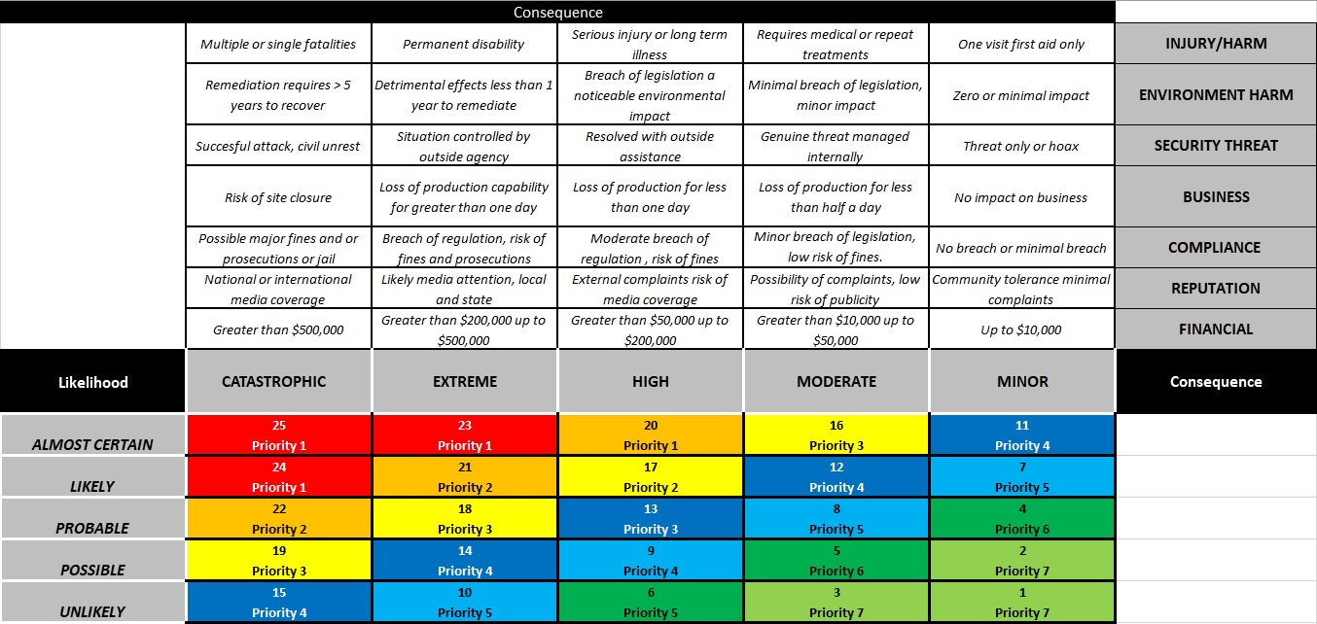
Hierarchy of Control
Eliminate - Remove the hazard
Substitute – Replace the hazard with a lower risk option.
Isolate – Keep the hazard separate from the team members.
Engineering – Use guards or physical controls to protect the team members.
Administrative – Introduce rules, training, guidelines or similar to increase competence and awareness of the hazard and it’s risks.
PPE – Provide suitable personal protective equipment that is effective in reducing the risks and outcomes of the hazard.

RISK MANAGEMENT / ASSESSMENT
What are the Hazards?  What can harm you - Hazards? | Who might be harmed and how? | Initial Risk Rating (without controls) | What are you already doing to control the risks? | Residual risk rating (With controls) | What further action do you need to take? | Who needs to carry out the action? | By when? | Done
Manual handling Deliveries, stacking shelves. | Staff may suffer strains or bruising injuries to their back or elsewhere, from handling heavy/bulky objects. | 8 | All staff are trained how to lift properly.  - High shelves for light goods only.  - Trolley available for moving stock such as newspaper deliveries, and staff trained how to use it safely.  - Stairs and corridors kept clear.  - Newspaper returns bundles kept to manageable sizes. | 4 | Remind staff that deliveries (except for stock that can be very easily carried) should always be moved using the trolley | Manager and staff | 08 Jan 22 | 05 Jan 22
 |  |  |  |  | Regular checks to make sure that high shelves are not used to store heavy stock. | Manager | From now on
Slips, trips and falls  Doorways (rain), spillages, stock on floor, uneven surfaces. | Staff and customers may suffer sprains, fractures or bruising if they trip over objects, such as stock, or slip on spillages and fall. | 9 | - Staff ‘clean as they go’.  - Wet floor warning signs always used.  - Shop floor is only mopped when shop is closed.  - Door mats at entrance in wet weather.  - Floor in good condition.  - Good lighting in all areas.  - Staff wear sensible shoes. | 5 | Staff to keep an eye on the area around the freezer and immediately clear away any meltwater. | Staff | 2 Jan 22 | 2 Jan 22
 |  |  |  |  | Remind staff stocking shelves not to leave boxes of stock in aisles, if suddenly called to help on the till. | Manager | 4 Jan 22 | 3 Jan 22
Violence Threatening behaviour | Staff may suffer assaults, threats and abuse from members of the public | 10 | - Staff trained not to resist a robbery.  - CCTV installed and clearly visible.  - Usually always two staff on duty. \  - Panic alarm located out of sight of customers, near the till.  - Staff provide good, polite service and are told not to confront customers.  - Staff report incidents of abuse etc and manager discusses with them (on a no-blame basis). | 3 | Contact local police station to get advice on what else can be done, eg safe procedures for opening and closing | Manager | 15 Jan 22 | 10 Jan 22
 |  |  |  |  | Manager to talk to staff about coping with disputes, eg shoplifting and age-restricted sales. | Manager | 20 Jan 22 | 10 Jan 22
Working at height  Changing light bulbs and promo displays | Falls from any height can cause bruising and fractures. | 5 | - Strong stepladder, in good condition, provided.  - Staff shown by the manager how to use stepladder safely, eg not to overreach, not to work on uneven floor etc.  - Staff wear sensible shoes with good grip. | 3 | Remind staff to always use the stepladder when working at height and not to stand on chairs. | Manager | 2 Jan 22 | 2 Jan 22
 |  |  |  |  | Manager to regularly check the condition of the stepladder. | Manager | From now on
Deliveries Unloading. | Staff or members of the public could be injured by being struck by a vehicle. | 9 | Most deliveries tend to arrive either very early, eg papers, or between 9.30 am and 3.30 pm, when road is less busy | 3 | Monitor deliveries to ensure they continue to arrive at less busy times. | Staff | From now on
Chemicals  Contact with bleach and other cleaning | Staff doing cleaning risk skin irritation or eye damage from direct contact with cleaning chemicals. Vapour may cause breathing problems. | 5 | • Mops, brushes and strong rubber gloves are provided and used. • Staff shown how to use cleaning products safely, eg follow instructions on the label, dilute properly and never transfer to an unmarked container. | 2 | Replace ‘irritant’ chemicals with milder alternatives, where possible. | Manager | 1 Feb 22 | 18 Jan 22
 |  |  |  |  | Staff reminded to wash gloves before taking them off carefully and storing in a clean place. | Manager | 10 Jan | 08 Jan
Electrical  Faulty building wiring, faulty electrical appliances | • Staff could get electrical shocks or burns from faulty electrics, including portable electrical equipment – heaters, fans etc. | 9 | - Staff trained to spot and report any defective plugs, discoloured sockets, damaged cable and on/off switches, and to take any defective equipment out of use.  - Staff know where the fuse box is and how to safely turn the electricity off in an emergency.  - Clear access to the fuse box.  - Qualified electrician does safety check of building electrics every five years. | 3 | Manager to do visual check of plugs, sockets, cables and on/off switches every three months. | Manager and Staff | From now on
Fire  Faulty electrics, arson. | If trapped, staff could suffer from smoke inhalation/burns | 5 | Fire risk assessment done, as and necessary action taken. Evacuation plan in place | 3 | Remind staff to keep backyard gate locked out of hours to stop intruders getting in. | Manager | 2 Jan 22 | 2 Jan 22
Work Environment  Cold temperatures, freezer work | Staff may suffer discomfort whilst stocking the freezer at work | 5 | Freezer gloves provided for use when restocking freezer. | 3 | Replace gloves when they are showing signs of wear and tear | Manager | From now on

Any Licences, Training required? | Fire warden & First Aid Training

Team Member Name | Team Member Position | Date | Signature
Mel Axford | Manager | 10 Jan 22
Harry Kane | Deputy Manager | 10 Jan 22
Eric Dier | Staff Member | 10 Jan 22
Laura Kenny | Staff Member | 10 Jan 22

